MUKTI RYAN SARI (RYAN)
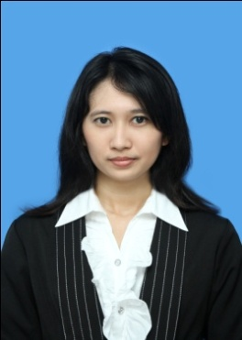
CAREER OBJECTIVE

Women 21 years old of experience in accounting field. Supported by good communication, good skill, discipline, hard worker, creative and innovative, fast receive new things, be able work in teams or individually.

EDUCATION

- Bachelor of Economics, GPA 3.6 (scale of 4)
Faculty of Economics, Accounting (2009-2013)
Sebelas Maret University
Skripsi : “ Pengaruh Diversitas Gender terhadap Kinerja Perusahaan (Studi Kasus pada Perusahaan-Perusahaan Go Public di Indonesia Tahun 2011) ”

- Senior High School 1 Karanganyar (IPA) (2006-2009)

WORK EXPERIENCE

- Internship in bank Indonesia Solo (1-15 October 2012)
- Volunteer Hello Garage Sale Solo (Cashier) (17-18 November 2012)
- Invigilator in Terbuka University (2-3 December 2012)
- Assist Data Collection (Accreditation of Economics Faculty UNS) (May,2 – June,7 2013 )

NON FORMAL EDUCATION & TRAINING
English for Academic Purpose | EAP (2009) | UPT P2B UNS Surakarta
Committee in the Accounting Society in Versatility (ACTIVE) | (13-15 October 2009) | UNS Surakarta
Participant in the Achievement Motivation Training (AMT) | (22-23 January 2010) | UNS Surakarta
Participant in the Character Building Training (CBT) | (13-14 March 2010) | UNS Surakarta
Participant in the seminar “Implementasi PSAK Terbaru Terhadap Pelaporan Pajak dan Pengaruhnya Terhadap Dunia Usaha” | (25-27 October 2010) | UNS Surakarta
English Active Communication | ELTI (2011) | Surakarta
Accounting Certification | Accounting Technician Professional Certification (13-14 May 2012) | UNS Surakarta
Participant in the Pre Job Training (PJT) | (18-19 July 2012) | UNS Surakarta
Participant in the Schools Capital Markets Basic and Intermediate Levels | (25-26 September 2012) | UNS Surakarta
TOEFL | (July 16 to September 6, 2013) | ILP Surakarta

ORGANIZATIONAL EXPERIENCE

Member of Himpunan Mahasiswa Jurusan Akuntansi (Research and Development) (HMJA) 2009 | Economics Faculty-UNS | 2009

INFORMATION & CONTACT

Adress
Jatisari, Sapen Rt 3 / Rw 2 Mojolaban Sukoharjo 57554

Phone
081393217822 / 085647007404

E-mail
muktiryansari@hotmail.com

PERSONAL DATA

Women 21 years old
Sukoharjo, October, 17 1991

LANGUAGES AND COMPUTER SKILLS

Language
English

Software :

Office applications
(Word, Excel, Powerpoint, etc)

INTERESTS AND HOBBIES

Music, Movies, Reading,
Interested in the fields of fashion, photography, technology, and social

