Curriculum Vitae

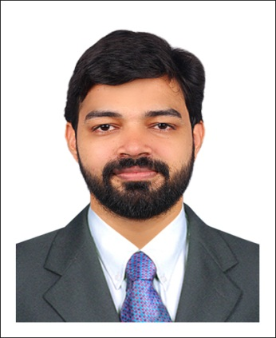
````````````````````````````````````````````````

MUHAMMED ASHRAF MP,

Melepeediyekkal,

Kannammoochiparambil House,

Thirurangadi (VIA),

Olakara ( P.O ),

Malappuram ( DT.),

Kerala,India, PIN : 676306.

Mobile: 919995507679
email:ashrafmpkoomanna@gmail.com
skype:mpmashraf313

OBJECTIVE:

To build a career in the field of teaching , writing , translation and interpreter with my creative& demonstrative skills

Executive Summary:

I am a very dedicated personality.I have a special pleasing talent in teaching.I am able to manage pupil and also perform as a team member .Creativity and hard work are my key words in my profile.

PERSONAL DETAILS

DATE OF BIRTH : 14th June1989

NATIONALITY : INDIAN

MARITIAL STATUS : MARRIED

SEX : MALE

RELIGION /CASTE : ISLAM/ MUSLIM

NAME OF FATHER : KUTTIALI MUSLIYAR MP

NAME OF MOTHER : AYISHA M

LANGAUGES KNOWN : ENGLISH,URDU,ARABIC& MALAYALAM

EDUCATIONAL QUALIFICATION:

Course |  | Qualified from | Year of passing
SSLC |  | Department of General Education | 2005
Plus Two |  | Board of Higher Secondary Education | 2007
BA English Language and Literature |  | Univesity of Calicut | 2010
B.Ed English |  | University of Kerala | 2016
MA English Language and Literature |  | Annamalai University | 2014
B.Ed (English) | University of Kerala |  | 2016

TECHNICAL QUALIFICATION

D.T.P (DESKTOP PUPLISHING)

MS-OFFICE

EXPERIENCE

I have teaching experience in:

- Yaseen English School Harni , Jammu and Kashmir : 2 years

- Najath Higher Secondary School Peruvallur , Kerala : 1 Year

- Manshau group of institutions Kannur , Kerala : 1Year

- Daffodils Concept School (ICSE) Sindhnur , Karnataka : 1 year

- Bright English School (CBSE) , cherukunnu, Kannur : 1 year

- Elegant IF English Medium School, Ner< Maharashtra : 1 year

STRENGTHS

  - Fully dedicated and professional approach towards my assigned job. Sincere and committed to the profession and to the firm in which I am a part.
  - The systematic innovation in extra curricular activities and extra stuffs in teaching
  - The researching approach towards the methods for extra effective results in teaching
  - Good perfomance as creative demonstrator and extacurricular staff executive , I have done a Documentary titled ‘Death for Sale’, based on the bad effect of smoking , for the students of Jammu and Kashmir
  - Second prize winner of DOCUFEST ’16 conducted by Majmau Da’wa college areacode for the docufiction ‘yukthimarikkunnidam’

SKILLS

Passionate to explore the magic of letters.

Creative and vibrant approach towards the profession.

The aura of personality is a trailblazer to build pro-company ambience among the team members.

Self-motivated and enthusiast

Interpersonal skills and creativity are the gems of work and career

DECLARATION

I hereby declare that all the information furnished above is true to the best of my knowledge and belief.

MUHAMMED ASHRAF MP

Sd/

