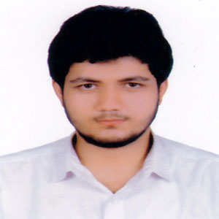
Resume of
Mokhlisur Rahman Boshir
278, College road, Kamrangirchor, Dhaka
Mobile: 01990436023
E-mail: bashir230799@gmail.com
Carrier Objective
To Work as a writer

Academic Qualifications
B.B.A. (Bachelor of Business and Administration)
Name of University: University of Dhaka
Major: Finance
CGPA: 3.45 (Till 2nd semester)
H.S.C (Higher Secondary Certificate)
Name of college: Notre Dame College
Group: Business Studies
passing Year: 2017
GPA: 5.00
S.S.C ( Secondary school Certificate)
Name of school: Armanitola Govt. High School
Group: Business Studies
passing Year: 2015
GPA: 5.00
Language Proficiency

 | Speaking | Recitation | presentation
Bangla | Excellent | Excellent | Excellent
English | Excellent | Excellent | Excellent

Skills
Excellent presentation skill
Good writing skills
MS Word (Medium)
MS Excel (Medium)
Interests

History
General Knowledge
Personal Information

Name : Mokhlisur Rahman Boshir
Date of birth : 23rd July 1999
Mother’s name : HosneAra Begum
Father’s name : Md. Bacchu Mia
Nationality : Bangladeshi
permanent Address : Nilkuthi, Mistiri bari, Raypura(P.S), Narshingdi
References

Mr. Khairul Alam Siddque
Lecturer,
Dept. of Finance
University of Dhaka
Phone: 01722712218
Mr. Md. Tanvir Hasan
Lecturer,
Dept. of Finance
University of Dhaka
Phone: 01918792116

Declaration
I do hereby declare that all of my information stated in this Resume is true to best of my knowledge and belief. And I will be responsible for any wrong information.

Signature

