PR
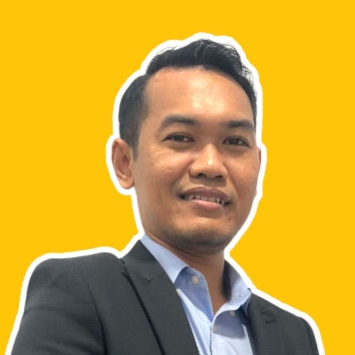  Personal DATA:  Name:  Mohd Fazli Bin Ahmad Isa  Address :  Lot 570, No. 46,  Kampung Padang Balang,  51000 Kuala Lumpur  Gender:  Male  Marital Status:  Married  Phone:  +6010-4435519  Email:  fazli_kaizer89@yahoo.com.my  LinkedIn Url :  www.linkedin.com/in/fazli-isa-3070bb95  Nationality:  Malaysian  EDUCATION:  - Bachelor Degree of Mechanical Engineering  National Defence University, Malaysia (2013)  - Science Matriculation  Pahang Matriculation College, Malaysia (2009)  - Sijil Pelajaran Malaysia (SPM)  Mara Junior Science College, Muadzam Shah, Malaysia (2006) | MOHD FAZLI BIN AHMAD ISA  ENGLISH <> MALAY TRANSLATOR
 | PROFILE SUMMARY
 | - A native Malay speaker with a proficiency in English, have knowledge in marketing as well as business, thus, confident that can produce a perfect Malay translation that meet the expectation, always understand the importance of translation accuracy and will try the best to make sure that the translation is 100% accurate besides will proofread and localize the translation so that there is no culturally sensitive words and grammatical errors that will affect the translation. Committed and able to follow instructions to deliver a high-quality work within the specified timeframe.
 | EMPLOYMENT HISTORY
- Freelance Translator
(Present)
Online Platforms
- Provide 100% pure translation, proofreading and editing services (English <> Malay) for companies and individuals all around the world through digital platforms

- Social Worker
(December 2015 - Present)
Department of Social Welfare (Malaysia)
- Providing 100% assistance and taking responsibility for disabled children's rehabilitation, moral support, and advisory services for Volunteer Organizations, such as Daily Care Centers for Disabled Children, Homes for the Elderly, and Orphanage Boarding Houses

- Engineer of Instrument
(June 2015 - November 2015)
J & M Power Resources Sdn. Bhd.
- Principally 100% engaged in engineering and trading of electrical instruments and related products

- Engineer of Bodyshop
(March 2014 - Mei 2015)
HICOM Automotive Manufactures (M) Sdn. Bhd.
- Managing on production and assembly of automobiles joint venture with 30% Mercedes Benz, 30% Suzuki and 40% Volks Wagen works

- Engineer of Technical Support Services
(November 2013 - February 2014)
CORROSERV (M) Sdn. Bhd.
- Handling project on 100% providing anti corrosion products that can be applied under water and above water, onshore or offshore.

ADDITIONAL WORKING CERTIFICATE
- Approved cert. as Graduate Engineer from Board of Engineering Malaysia (BEM)
- Effective Time Management Attendance Course Certificate

SKILLS & PROFICIENCIES
Language Skills:
- Malay (Spoken & Written)
- English (Spoken & Written)

Hard Skills:
- Ms Office (Word, Excel, PowerPoint,)
- Canva (Banners, Slideshows, Videos, Posters)
- Translation, Proofread, Edit, Subtitle, Localize (General Translation, Academic Translation, Science and Engineering Translation, Marketing and Business Translation, Science and Medical (General) Translation
- Copywriting
- Machine Learning
- Project management
- Content creation
- Data analysis

Soft Skills:
- Communications
- Time Management
- Teamwork
- Willingness to learn
- Creativity

ACHIEVEMENT & PARTICIPANTS
- 2012 – Royal Commission as Second Lieutenant in military reserve force of the Malaysian Army (Rejimen Askar Wataniah) from Reserve Officer Training Unit (ROTU), National Defence University, Malaysia.
- 2010 - 2013 –Special Envoy of Pahang Youth Student Council under Pahang State Foundation from National Defence University, Malaysia

