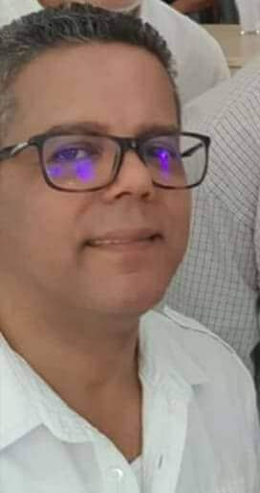

ç

***Ben Gamra Mohamed Neji***

**DIPLOMAS Y HOBBIES**

**Formaciones :** Diplomados, Congresos, xxxxxxxxxxxxxxxxxxxxxxxxxxxxxxxxxxxxxxxxxx

**Hobbies:**xxxxxxxxxxxxxxxxxxxxxxxxxxxxxx



***Editor-in-chief***

**Objective**

My main task is to research, verify and transmit information for various media (print or online), making it comprehensible and accessible to different audiences (readers, listeners, television viewers, Internet users, etc.).

**CONTACT**

**Education**



+216 99381139

[bgamraneji@gmail.com](mailto:bgamraneji@gmail.com)

04 STREET FARHAT HACHED

2010, MANOUBA, TUNISIA

**Master's degree in English literature and translation, University of Tunis, Faculty of Arts, Manouba**

©AZURIUS – Modeles-de-cv,com

**Professionnal career**

* Writing for web and print content
* Collecting and organization of information
* Perseverance
* Team collaboration

**Skills**

,viewers,inter

**Reporter and translator at Tunis Afrique Press news Agency (TAP) "Manar 2", Tunis:** drafting of agency articles, press releases, reports and articles on the presidency of the republic, the prime ministry, the ministries of foreign affairs, defence, the interior, justice, social affairs and cultural affairs, as well as articles on national political news. I also translate reports and articles on various subjects into Arabic, French and English.

**From 1994**

0

**Integration into the economic and financial desk of the press agency:** coverage of government activities for the ministry of finance, Agriculture, commerce, industry, environment and new technologies as well as the development of background documents and the monitoring of different structures such as the Tunisian union of industry, Trade and Handicrafts (UTICA), the Export Promotion enter (CEPEX), the Central Bank of Tunisia (BCT), the Tunisian union of agricultural and fisheries (UTAP) as well as the supervision of updating the web site as head of the multimedia.

Writing press releases, concept notes and press files, website revision project management editing as well as writing on the regional reports as part of the zoom on the regions of Tunisia

**Training**

* Arab States Broadcasting Union training (ASBU)
* Algerian news agency training (APS)
* Training at the Portuguese news agency (LUSA)

Part-time consultant and editor in chief of teletext department of the Tunisian television channel 1, daily news update

**2000 – 2012**

Co-founder and editor-in-chief of online magazine of english language*: http:// tunisianmonitoronline.com/* as well as independent journalist and translator for the magazine”Gazelle” the magazine “the Economist”and translator in the Word Summit on the Information Society (WSIS) held in Tunisia.

**Languages**

**From 2016**

English : Excellent

French: Excellent

Arabic : native language

Contribution to a study on the treatment of the returnees from the hotbeds of tension in collaboration with the British Council in Tunisia

**2019–2020**