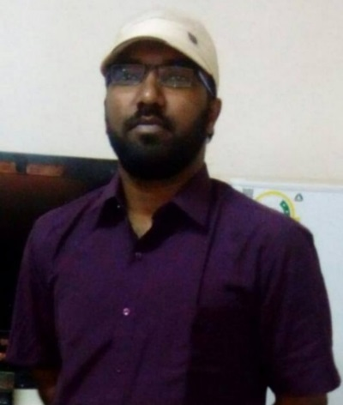
MOHAMED MOHIDEEN ABUL KALAM
Tamil Translator
16, SALAI NAINAR PALLIVASAL (PO), MAVADI (VIA), NANGUNERI (TK), TIRUNELVELI (DT), TAMIL NADU, INDIA.
PIN: 627107
📱 +919025537215
✉️ammdeen86@gmail.com

Summary
Results - driven and detail oriented freelance translator with a proven record of success in translating various materials from English to Tamil and vice versa, Transcription, and other language services.

Experience
Tamil – English freelance Translation and Transcription
(Over 15 years of experience )
- To Translate from English to Tamil and vice versa.
- Human Translation
- Creative Translation
- Localization
- Medical Translation
- Editing, Reviewing, Proof Reading.
- To transcript video and audio between English – Tamil language set.
- Check for accuracy and edit files.
- To prepare letters, report’s and write content.
- Maintain confidentiality around sensitive information.
- To handle classes in English Grammar.
- To offer situational conversation practices.
- To train candidates in Neutral Accent.
- Presenting speech in different topics.
- Soft Skills training.
- Conducting language oriented tests.
- To prepare practice materials.
- To train candidates for IELTS Exam and Call Centre Concepts

EDUCATION
MASTER OF JOURNALISM AND MASS COMMUNICATION – 2014 | ALAGAPPA UNIVERSITY, KARAIKUDI, TAMILNADU, INDIA.
BACHELOR OF COMPUTER APPLICATION - 2011 | ALAGAPPA UNIVERSITY, KARAIKUDI, TAMILNADU, INDIA.

LANGUAGES KNOWN
- ENGLISH - READ, WRITE & SPEAK (FLUENT)
- TAMIL – READ, WRITE & SPEAK (FLUENT) (Native)
- MALAYALAM - SPEAK (FLUENT)
- URDU - SPEAK (FLUENT)
- ARABIC - READ, WRITE, SPEAK (Basic)

SKILLS
- M.S.OFFICE
- XLIFF EDITOR (Translation Software)
- MateCAT (Translation Software)
- TexLang Platform (Transcription)
- Dubverse
- Translation Softwares.

