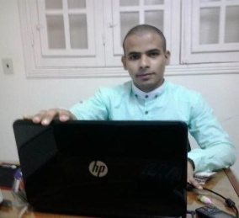
Personal summary
I am a talented translator with a proven ability to translate written
Documents from a source language to a target language
Personal details
Name: Mohamed Hamed Abdel Maged
Date of birth: 18, Oct, 1992
Military status: Completed
Marital status: Single
Education & Qualifications
University: Helwan, faculty of Commerce and Business Administration
Department: Economics and Foreign Trade
Graduation Year: July, 2013
GPA: Good, (C, 20)
Work Experience
Experience | Position | Business | Company name
Teamwork | Storekeeper | Household | Afaq for trading
Teamwork | Call center | Engineering works | Nobel
Teamwork | Technical Support | Software development | ClearVision
Teamwork | Data Entry | Household maintenance | Trade for Egypt
Computer skills
- Highly skilled in Word, Excel and Microsoft Outlook.
- Professional typing rate of 50 (word per minute).
- Good at using Computer with all its versions.

Language skills
I would like to work as a translator for a successful and ambitious company that offers great opportunities for career development and progression.
Excellent at English (Writing & Speaking)-
- Involved converting documents and articles from one language into another.
- Working freelance for a translation agency providing a translation and interpretation service to clients where needed.

Contact Details
Mob: 01224696016 Email: mataria_lumia@live.com
Address: 10 Belal St, El Mataria, Cairo, Egypt

