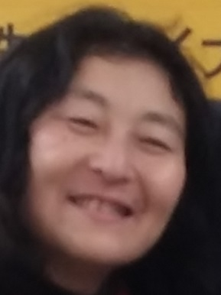

My Contact Information
First Last Name Michiyo Oosterwjik
Street Address 2-3-5 Kandaiji Kanagawa-ku Kanagawa, Yokohama, Japan 221-0801

Career Summary / Highlights
I have been working as a translator for last 9 years in different places such as in Ghana, Slovenia, Germany, and here in Japan. Mostly writing translation as well as interpreter and coaching
I have been travelling around the world such as in Slovenia, Croatia, Germany, Austria, Holland and so on. I have been helping many people as volunteer Christian worker. During the time I did some translation work off and on for last 10 years or even more.

Experience Italiya Co.ltd.
City, State Tokyo Japan, Shibuya Daikanyama
Dates Worked 1984 April-1985 March.
Job Title
Assistant accountant Shop keeper
Seiyu Super Market Co., Ltd. Travel Division
City, State Yokosuka, Main Branch in Ikebukuro Tokyo Dates Worked 1987-04—1998-3
Job Title
Counter manager at Yokosuka Branch Project member for QE2 project on 1991
Chief of the sales department and organizational department for branches

Volunteer worker as Christian leaders in various projects.
1991-2011
2011-Present
Self-Employee as English teacher for Fun Fun English
Argan Oil Japan as Personal importer from Morocco to Japan.
Part time translator as freelancer for regular base work.

Education
1974 Yokohama Public Minami Kandaiji Elementary school Graduated 1978 Nagasaki Public Yamazato Middle school graduated
1981 Junshin (Pure Heart) girls senior high school graduated
1983 Yokohama Academy College measured Travel service and English course
2001 CVC Christian Vocational College course of Christian leadership/Ordinated to be a pastor

Skills
Office programs intermediate level/ Translation English-Japanese/Japanese-English Full understanding of English (TOEIC score 880) /Education field for teaching young children/Healthrelated/Computer/IT/Legal/Beauty/Manual/Literature/History/Script writing translation/copy writing/Mobile phone manuals/It manuals

