Curriculum Vitae

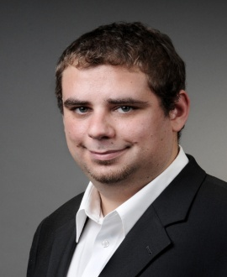

Personal Information

Date of birth: 09/14/82
In: Cologne, Germany
Family status: not married

Mother tongue: German
Working Languages: Arabic, Portuguese, English

Fields of expertise: Business&Finance, Marketing, Law, Tourism

Prices: Arabic->German 0.10-0.12€/word
Portuguese->German 0.08-0.10€/word
English->German 0.06-0.08€/word

CAT/TM: Working with Across, experienced in using Trados

Working Experience 3 years, various free lance jobs for companies and
as Free Lancer agencies, such as 3p S.A., Intermundos, Delta Soft

Education
10/2004 – 09/2011 FTSK Germersheim, University of Mainz
Graduate Studies in Translations
             ▪ First language: Arabic, second language: Portuguese
             ▪ Specialized in economy related translations
             ▪ Scientific seminars on Culture, Linguistics and
Translations
             ▪ Committees: Elected member oft the student
parliament for 3 consecutive years

09/03 – 05/04     Civilian Service, Cologne        

08/93 – 06/03 Johann-Gottfried-Herder-Gymnasium, Köln
(Secondary School)
Graduation: University-Entrance Diploma, Majors: English,
History
Internships
06/11 – 09/11 Diving Almata, Empuria Brava, Spain
             Bilingual Secretary 
             ▪ Tasks: Person of contact for clients from all over
Europe; Make appointments and coordinate those with
diving instructors; Giving first diving instructions in
German, English, Spanish and French

Computer literacy Very good computer and internet skills (MS-Office,
Windows, Adobe), CAT/TM experienced

Working Experience
01/12 – today ABH Market Research, Cologne
Call Agent (Surveys in English and German)
2005 – 2008 ABH Market Research, Cologne
Call Agent (Surveys in English and German)
1999 – 2003 Beverage Store, Cologne
part time after school; home delivery 2001-2003

Interests languages, cultures, travels, sports, music, literature,
computer

Cologne, July 17th 2012 