Background
Merve Erpak  Caferağa mah. Hacı Ahmet Bey sok.  Barış apt. No:7 D:4  Kadıköy/İSTANBUL  Mobile.: (538) 7391000  (555) 8411000  E-mail: merve.erpak@hotmail.com  merve.erpak@gmail.com |  | Sex : Female  Date of birth : 09/06/1987  Marital Status: Single  Nation : T.R.  Driving Licence : Class B | 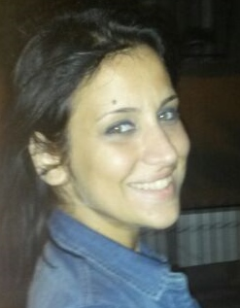

CAREER TARGETS
In a short term, improving myself in accordance with my educational background and my skills.
In a long term, to be promoted in appropriate position by adding value to company and to my career.

EDUCATIONAL BACKGROUND
Second University | Kocaeli Üniversitesi –İzmit – English Language- 09/2013 -
University | Trakya Üniversitesi – Edirne – Balkan Language/Bosnian – 09/2007 – 06/2012
High School | İnegöl Lisesi – Bursa – English– 09/2001 – 06/2004

WORK EXPERIENCES
07/2013 – 03/2014  01/2013 – 04/2013  09/2012 – Still | Edu Translation Office- İstanbul  Departmant : Translation  Position : Translator – Full Time  Altın Koza Mobilya – Bursa/İnegöl  Departmant: Export  Position: Exporter  Yazım İşleri – Ankara  Position: Freelancer  Definition; Translating, Content Advisor, Editing.

Courses and Training
15/07/2013 | Translation Training  Corparate: Edu Akademi  Graphical Designing and Advertising  Corparate: İsmek  Subject: Photoshop, InDesign and Illustrator programs are taught.

Computer Skills
Word, Excel, Powerpoint, Outlook: Excellent
Trados 2007, Trados 2011 Studio, SDLX, Across, WinAlign: Excellent
Xbench: Good

Language Skills
English | Reading: Excellent Writing: Excellent Speaking: Good
Bosnian/Serbian/Croatian | Reading: good Writing: good Speaking: not bad

Specialities
Medical, technical, IT translations.
Hobbies
Tennis, swimming, walking with my dog, music, reading.
References
Ceyhun Bölge | Edu Çeviri – QA Manager – Mobile: 0533 617 97 61
Sema Sandalcı | Trakya Üniv. – Doç. - Mobile: 0533 726 16 12
Turgay Tansal | Oyak Renault – Mobile: 0532 312 91 31

