Mehmet Basoglu
Personal information
Email address: | Mehmet Basoglu | 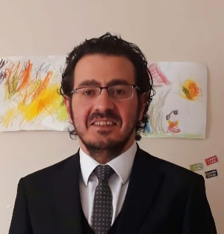
Phone number: | 00905355789543
Address: | Cankaya,Ankara
E-mail : | memetbasoglu@hotmail.com

Profile
Experienced legislative expert with more than 15 years of experience in general, budget and tax legislation. Expert in data analysis and problem solving, with great attention to detail and a strong ability to work under pressure.

Professional experience :
October 2009- present | A legislative expert  Grand National Assembly of Türkiye, Ankara

Education:
September 2000 - June 2007 | BA in Public Finance, Istanbul University
Jan 2020 | MA in Media and Cultural Studies, METU, Middle East Technical University, Ankara, Türkiye

SKILLS
- Fluency in English
- Beginner level,Spanish and Arabic
- MS Office

