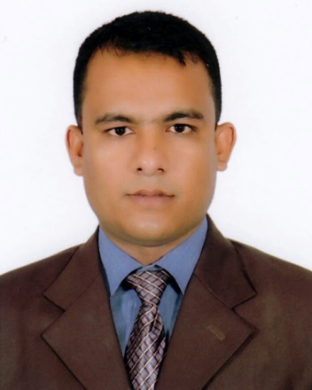
CURRICULUM VITAE
OF s
[
MD. KHALID HOSSAIN

Present Address :
Taliamari, Boalia, Rajshahi.
Mobile: +8801612444522, +8801557220963
E-Mail: khalidshipu2325@gmail.com

Carrier Objective
To build career working in a challenging environment with excellent career development prospect, where hard work, strict discipline, good communications skill & creative problem solving are the corner stone of success in the field of home and abroad.

Academic Certification

- Name Of Exam : Bachelor Of Business Administration (BBA)
- Passing Year : 2008
- Institute : Darul Ihsan University, Dhaka.
- Subject : Marketing
- Result : G.P.A-3.05 (out of 4.00)

- Name Of Exam : Higher Secondary School Certificate (HSC)
- Passing Year : 2003
- Institute : Charghat M A Hadi Degree College.
- Board : Rajshahi
- Result : G.P.A-3.30 (out of 5.00)
- Group : Science

- Name Of Exam : Secondary School Certificate (Dakhil)
- Passing Year : 2000
- Institute : Sonadah High School
- Board : Rajshahi
- Result : First Division
- Group : Science

Language Proficiency

Language Reading Listening Writing Speaking

Bengali High High High High

English Medium High Good Good

Computer Skills

Software: MS Word, MS Excel, MS PowerPoint, C++,
Operating System Windows 7, Windows 8-10 & Latest Version.
Communication: Email & Internet Browsing.

Personal Skill

- To Do Something New And Challenging & Also Traveling.
- I Am A Quick Learner And Capable To Adopt With Any Kind of Situation.
- I Have A Very Good Mental Strength And Always Enjoy Facing any Challenges.
- I Am A Good Team Worker and Always Friendly With My Colleagues.

Personal details

- Name : Md. Khalid Hossain
- Father’s Name : Late Sakender Ali
- Mother’s Name : Mst. Tofizan Begum
- Permanent Address : Vill: Sonadah, P.O: Sonadah Bazar
- P.S: Bagha, Dist: Rajshahi
- Date Of Birth : 31-12-1984
- Religion : Islam
- Nationality : Bangladeshi (By Birth)
- Gender : Male
- Marital Status : Married

Experience

Organization : Bangla Media Corporation
Designation : Executive, Marketing
Duration : 01/01/2013 to 30/06/2015

Organization : Idea Advertising Agency
Designation : Manager, Marketing
Duration : 01/07/2015 to till now.

Reference

Md. Nazibullah  Technical Manager  Urmi Group  01713-339719 | Md. Saiful Alom Bhuiyan  Senior Manager  Interior Works Department  Asset Development and Holding Ltd.  01714-046824

Declaration

I hereby declare that the particulars finished about are true and correct to the best of my knowledge.

......................................
Md. Khalid Hossain
Date :

