CURRICULUM VITAE

Name: Md. Zakir Hosen
Founder | CEO
Language Service
Email: zakirmse641@gmail.com
Contact Number: +8801774275641
Myself
I am a professional English<>Bengali translator and proofreader. I have 4 years of experience. I have established Language Service as a leader in Transcription and translation markets.
Experiences
Transcription (Bengali to Bengali)
Tools: Shaip, Loft 2 etc.
Subtitle Task
Done some projects and have experience in Adobe Premier Pro tools.
Portfolio: https://sites.google.com/view/portfolio-zakirhosen
My proz profile:http://www.proz.com/profile/2849147
Linkedin profile: https://www.linkedin.com/in/md-zakir-hosen-3689b115b
Expertise (Domain) | Used Tools | Daily Output | Rate (Negotiable)
Medical, Marketing, General, Technical, , Finance, Scientific, Engineering, IT, E-Commerce, Educational, Legal etc. | SDL Trados, Wordfast, SmartCat, Memsource, | Translation: 4,000 plus/Day,  Proofreading: 9,000/Day | Translation:  $0.02USD/Word  proofreading:  $0.01USD/Word

Name of the Agency | Address/Website | Position  (English<> Bengali) | Duration
Linguaworldservices | https://linguaworldservices.com/ Kanti Nagar Extension, Near Welcome Metro Station, New Delhi, Delhi 110051  Mobile: +91- 9311112424 | (English<> Bengali) | 2022 to Present
Transoplanet | https://transoplanet.com/  India, VIP Road Guwahatin,  phone: +91 98640 72186 | Translator and proofreader | 10-04-22 to Present
Somya Translators Pvt. Ltd. | http://somyatrans.in/  ISO 17100:2015 Certified  Market, Pandav Nagar, Delhi -110092  Phone: +91-11-43061918, 22486881 | Proofreader | 10-04-21 to Present
Parikh Info Solutions Pvt. Ltd. | https://parikhinfosolutions.com/  Mob: +91 9867480366  Maharashtra, India. | Proofreader & Translator | 01-06-20 to Present

No. | Name | Email/phone | Agency
1. | Binod Ringania Director | binod@transoplanet.com  phone: +91 98640 72186 | Transoplanet
2. | Amitt Parikh  Director | amitt@parikhinfosolutions.com  Skype: amitt.parikh | Parikh Info Solutions Pvt. Ltd.
Reference:

Also completed several English>Bengali translation project through several translation sites since 2018.
More than four years of experiences on Translation, Data Entry and Transcription work as a freelancer.
A registered member of TranslationDirectory.Com, Proz.com, TranslatorsCafe.com, Fiverr and People Per Hour freelancing sites since 2018.
Language Skill
- Excellent capability over English and Bengali on reading, writing, listening and speaking.
Computer Proficiency
I have an excellent knowledge & experience on the following programs:
Microsoft Word, Excel, Access, Power Point, Translation and Internet Browsing.
Educational Qualification
M.Sc. Engineering (2020)
Department: Materials Science and Engineering (M.S.E)
Passing year: 2023,
Result: 3.91 (Out of 4)
Institution : University Of Rajshahi;

B.Sc. Engineering (2019)
Department: Materials Science and Engineering (M.S.E)
Passing year: 2019,
Result: 3.52 (Out of 4)
Institution : University Of Rajshahi;

Interested On
Reading Newspaper, learning and Traveling.

I hereby declare that the above statements are true to the best of my knowledge.

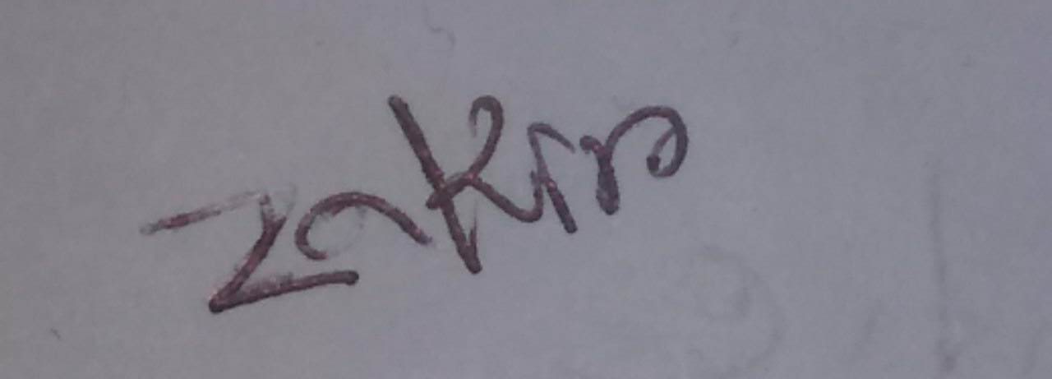

Date: 01/02/2024 Signature

