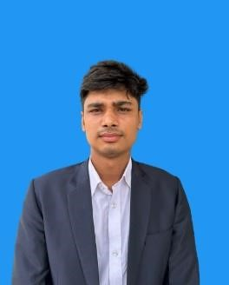
Md Saikot Mia
Jamdani, Pirganj, Rangpur
Call:0177549632
Email:soikot5th@gmail.com

Objective
I am a dedicated English-to-Bengali translator and article writer with 2 years of experience working in professional communities. I have accurate translation skills including simultaneous translation between all parties during teleconference and in-person meetings and I am an experienced article writer in researching, writing, and publishing compelling content result-driven the production of meaningful and original work for media platforms and clients.

Educational Qualifications
Exam title | Major | Passing year | Institute | CGPA
BBA(IBA) | HRM | On Going | University Of Rajshahi | 3.50
HSC | Commerce | 2019 | Polshbari  Government college | 4.50
SSC | Science | 2017 | Bishnupur High School | 4.64

Working Experience
- 2 years of working experience in content writing in Carrefour and case study (from 2022 on) and former document translators. Completed final project translating proprietary scientific study materials, including procedures, observations, methodologies, and results.
- 3 years of experience in Rajshahi University English Language Club and a current associate member of this club.
- Associate member of Rajshahi University Business Club and former Associate member of Rajshahi University Higher Study Club.

Core Qualifications

- Translation
- Article writing
- Transcription
- Proofreading and editing

Language

- Bengali (Native)
- English fluent (written and Oral)

Area of specialization

Business Organization and Management, Marketing Research, Brand Management, Advertising policy making, Case study, Tourism management, Contract and agreements, Free hand writing, Social and development.

Personal information

Nationality : Bangladeshi
Present address : Binodpur Rajshahi
Permanent address : Prganj Rangpur

Reference
Available on request,

