Mariam Mkheidze

- Date of Birth: 25.08.1995
- Nationality: Georgian
- Address:#85, I.Abashidze str., Tbilisi, Georgia
- Mobile:+995 555 221814
- Mail: mariammkheidze@gmail.com

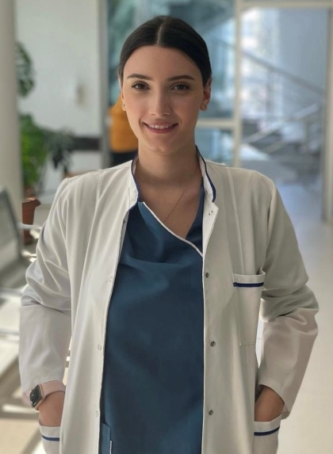

- Education:

- Clinical Residency – ChichuaMedical Centre “Mzera” – 2021- ongoing
- Clinical Residency – Kharkiv Medical Academy Of Postgraduate Studies- 2019-2020
Ophthalmology Department of Kharkiv city clinical Hospital#14 named after prof. L.L Girshman, Kharkiv,Ukraine
- Tbilisi State Medical University, 2013-2019
Faculty of Medicine ,

- High-School: IB-Mthiebi -2013.

- Work experience:

- Translator for several international companies since 2012.
Language pairs: Georgian-English-Georgian, Russian-English-Russian

- Clinical Translator, proofreader,copy writer- 2022 July-2023 February- Kalitetcerume solutions
- English-Georgian Translator- 2022-ongoing – at Janus Worldwide
- Centigen LTD- Project Based Freelance Work as a Project Manager ,
Responsibilities:
* Scheduling management for product lead.
* Document and clerical management for product management team.
* Communication management with multi-national project stakeholders
* Intrateam scheduling and communication management– 2017-2022
- Translator, subtitling editor, Proofreader (English)- 2021- ongoing- at Appen Company
- English-Georgian Translator– 2019- ongoing- at The Language Room
- Senior Translator – 2018- 2021- at Nona Jishkariani Translating Company
- Translator – 2018- ongoing- at Lionbridge Company

- Assistant Doctor, Tbilisi, Georgia
- Assistant Doctor-2018- 2019- at “Curatio Clinic”, Department of Ophtalmology
- Russian Language Translator 2017-Present- Onespace
- Assistant Doctor-2014- 2015- at “Elisabeth Blackwell hospital”, Department of Internal Therapy
- Translation Team leader 2013-2021- at Onespace
- Subtitling , copywriting , game translation- 2011- ongoing- at Onespace

- Languages:

Georgian- Native English- C1(Certificates: Council of Europe Level C1Certificate)
Russian-C1 German- B1

Computer Programs
MicrosoftOffice,Indesign, Adobe Photoshop, Memsource, Trados

- Trainings/Seminars

- Cybersight -Ocular Complications of Medications Webinar 2021
- Cybersight -Uveitis Therapeutics: Noninfectious Uveitis Webinar 2021
- Cybersight -Lacrimal Duct Obstruction in Children Webinar 2021
- Cybersight -Dry Eye: Evolving Diagnostics and Care-2022
- Cybersight -Personalized Treatment for Keratoconus Webinar -2022
- Cybersight -Uveitis Therapeutics: Noninfectious Uveitis Webinar 2021
- Erasmus Plus- 6 month exchange program at Lublin State Medical University-2018
- Summer internship- Lower Saxony International Summer Academy (LISA)- 2017
- Summer internship - Department of Internal Medicine, Faculty of Medicine of OndokuzMayis UniversityCertificate2015.
- First student Olympiad
LOGICSER spring season - Diploma2015.
- NATO Youth summit - Certificate 2012.
- Youth Vision Georgia-Debate Tournament - Certificate-2012.
- Tbilisi State University- summer science academy-Diploma/Certificate- 2011.
- Georgian Red Cross Society - Resource mobilization international seminar Certificate2011.
- English Language Summer school-Saint Dunstan’s university- Certificate 2011.

