Maria Luisa Retiro Poliarco
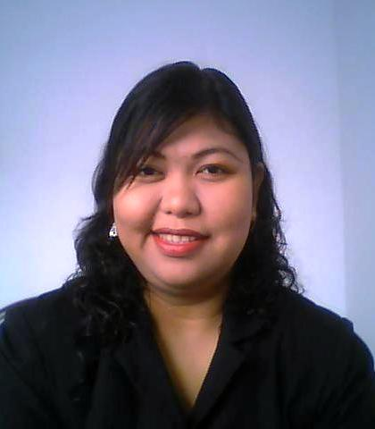
Home Address: Unit 1114, Celesta Bild., Cypress Towers,
C5-Road, Taguig City, Philippines
Email: gtn.phils@gmail.com Phone: 09166249476/2349644

Experience | 2014 – Present Truvalue Pharma Corporation Ususan, Taguig  Consultant  - Business Consultant  - Helping Marketing to establish contact  - Giving training  2012 – 2014 Amikat Services Inc. Global City, Taguig  Sales Support Consultant- For Malaysian Account  - Making more than 100 calls per day  - Making more than 70 effective calls per day  - Activation consistent above average  - MVP of December 2012 with 15 Activation  - MVP of January 2013 with 31 Activation remarking international record  - Meeting personal goal  - Contributes to reach team’s monthly quota  2009 – 2012 Mapalad Pharma Corporation Manila, Philippines  Office manager/Incorporator  - Managing the office and the staff  - Control the financial flow of the company  - Responsible for the good performance of the staff  - Authorized and responsible for smooth conduct of all meetings with the clients  - Authorized and responsible for entering into any agreement related to business  - Authorized and responsible to any purchase on behalf of the company  - Speaker/Chief of Guest for International Conference on Global Marketing strategies & Practices Organized by Nehru Group of Institute, TamilNadu, India  2008 – 2009 Calvary Charismatic Centre Sabah, Malaysia  Accountant  - Monitoring/Controlling the flow of income and expenses of 42 outreach (branch) churches.  - Doing Balancing and updating weekly income and expenditures  - Translator for Guest Speakers English to Malay/ Book translator- English to Malay  2006 – 2008 Glorious Praise Fellowship LTD Hong Kong  Missionary  - Mainly teaching Christian Education at the Drug Rehabilitation Centre  - Giving a Music Training at the Drug Rehabilitation Centre  - Helping in administration work and book keeping for the Rehabilitation Centre  - Visiting prisons  - Giving counseling to Filipino & Indonesian Domestic Helper
2004–2006 Maunlad Corporation Davao, Phil.
Corporate Treasurer/Incorporator/Manager
- Handling meetings with farmers, investors and government representative
- Responsible for 75 workers wages and workers performance
- Handling importation of seedlings and other materials
- Controlling of financial outgoing expenditures
2003–2004 Word Of Hope Manila, Philippines
Secretary/Minister
- Mobilized missionary to different places in Malaysia and teach about Mission.
- Organized Mission trip for Missionary and minister to Malay tribe in Malaysia.
- Implemented training course for new Missionary for Malay Tribe.
- Conducting Praise and worship seminar to different churches
2000–2002 Calvary Church, A/G Kota Kinabalu, Malaysia
Part Time Bible School Student/Pastor
- Completing Bible School Course Bachelor in Biblical Studies Major in Church Administration
- Equipping Malay tribe in Mission and Evangelism
- Pioneered a new Malay church under Calvary Church
- Pioneered a Filipino church
- Conducting Praise and worship seminar to different churches.
- Translator for Guest Speakers English to Malay/ Book translator- English to Malay
1999–2009 Calvary Church, A/G Kota Kinabalu, Malaysia
Church Office Administrator/Mission Coordinator
- Administrate church office
- Distributing works for 23 staff
- Main Organizer for any church big events
- Responsible for any church events advertisement including artwork design for weekly newsletter and annual newsletter
- Supervising interior Mission churches
- Conducting Praise and worship seminar to different churches.
- Translator for Guest Speakers English to Malay/ Book translator- English to Malay
1997–1999 Calvary Church, A/G Kota Kinabalu, Malaysia
Bible School Student/Full Time Worker
- Studied in Malay Bible School at the same time working in the church
- Involve in Pioneering work at remote area and to malay speaking people in Malaysia
- Pastor for Malay youth and Praise And Worship Ministry in the Church
- Head of Church Mission and Evangelism Ministry
- Conducting Praise and worship seminar to different churches.
- Translator for Guest Speakers English to Malay/ Book translator- English to Malay
Education | 2000 – 2003 Pusat Perlatihan Calvary Kota Kinabalu, Malaysia  - Bachelor in Biblical Studies Major in Church Administration  1997–1999 Pusat Perlatihan Calvary Kota Kinabalu, Malaysia  - Diploma in Pastoral Ministry  1995–1997 Kinabalu Collage Kota Kinabalu, Malaysia  - Computer Course  - Office Administration  - Secretarial Course  1989–1994 S.M.J.K. Tiong Hua Sandakan, Malaysia  - Secondary 1 to 5  1983–1988 S.K. Berhala Darat Sandakan, Malaysia  - Primary 1 to 6
Language Skill | Bahasa Malayu  - President of “Bahasa dan Sastera” (Language and Literature) from Secondary 3 to Secondary 5  - School Representative for Bahasa Speech Competitions (Pidato) from Primary 5 to Secondary 5.  - School Representative for “Perbahasan” (Debate in Malay) from Secondary 1 to 5.
Other Skills | - - Excellent oral and written English and Bahasa Malaysian/Indonesian communication skills.  - Translate books from English to Bahasa Malaysia  - - Developed computer skills Word, Excel, Publisher, Powerpoint, Explorer, etc).  - - Professional Phone Manner  - - Ability to handle multiple tasks.  - Ability to adhere to all organizational policies and procedures.

References
- Christopher Dotimas / 09178730211
- Arlene P. Buenavidez / 09063015158

