CURRICULUM VITAE
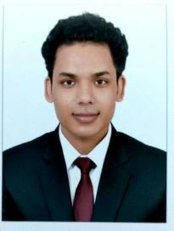
NAME: MANOJ JEENA

Address: Near Nirmala school ,Kathgodam, Nainital (UTTARAKHAND)
Postal Code: 263126
Date of Birth: 05/dec/1993
Gender: Male
Marital status: Unmarried
Nationality: INDIAN
Language known: Hindi, English

Telephone Number: (+91)8755893383
E-mail address: manojjeena21@gmail.com

CAREER OBJECTIVE: To be the part of a reputed organization which provides steady career growth along with job satisfaction, learning and challenging environment which help in utilizing my skills and knowledge and give valuable contribution in the success of organization.

EDUCATION QUALIFICATION:
- High school: St.Theresa SR Sec School, Kathgodam (Uttarakhand) 62 % Grade
- Intermediate: NATIONAL INSTITUTE OF OPEN SCHOOLING with 53% Grade
- Bachelor’s: IHM GOA - BSc in Hospitality and Hotel Administration Completed in 2017

WORK EXPOSURE:
- Successfully completed Industrial training from
CLARKS INN HOTEL, HALDWANI, NAINITAL(UTTARAKHAND)
LEARNED:
- Get basic knowledge about hotel & hospitality industry
- Learned to manage day to day tasks

- Worked as a transcriber(Hindi/English) at Appen.

- Worked as a QAS (Hindi/English) at Appen.

- Worked as a Freelancer Translator (English to Hindi) at Appen

INTEREST & HOBBIES:

Cooking

Listening music

Playing cricket

Traveling

Photography

SKILLS:
- Communication
- Writing
- Team work
- Leadership
- Multitasking

