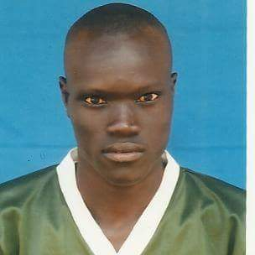 |  | Mangar makuach manghu  TRANSLATOR/INTERPRETER  Two years of full Dinka -English translation and interpretation experience
Profile  I look forward to enhancing my expertise in English-Dinka translation. I'm targeting to explore and have hands-on experience in all Dinka dialects. It is interesting choosing this path.  Contact  PHONE:  +254722338316  EMAIL:  panmanghu@yahoo.com  Hobbies  - Nature walk (visiting natural sites)  - Enjoy reading non-fiction books  - Like sporting activities  Achievements  - In 20013-2014, I served as a class representative in college. In the same academic year, I was serving as a Secretary General of International Student Guild (ISG), a body that was formed to put together the international students in the University.  - In 2008-2009, I was appointed as house perfect before being elected as school Captain (Head Boy) in 2009-2010 |  | EDUCATION  CAMBRIDGE INTERNATIONAL COLLEGE  2017 - 2018  Diploma in International Relations and Diplomacy and I graduated  With merit.  MASINDE MULIRO UNIVERSITY OF SCIENCE AND TECHNOLOGY  2012 - 2014  Diploma in Information technology and graduated with credit I  WORK EXPERIENCE  UNITED NATIONS HIGH COMMISSIONER FOR REFUGEE (INTERPRETER/TRANSLATOR)  July 1st, 2017–to date  Dinka-English Translations and interpretation. Delivered the services of translation and interpretation diligently to the satisfaction of my clients and UNHCR staff.  NASIB SECONDARY SCHOOL (TEACHER)  October 2015–April 2016  ICT teacher and made sure skills were well rendered to the students. This was well manifested in their top performances.  SKILLS  - IT training  - System and network security  - Equipment and tool maintenance  - Translation and interpretation  References  Ismail Abdiwahab: UNHCR sub-office Dadaab Assistant field officer.  Mobile phone: +254726397396  E-mail: ismaila@unhcr.org  Suleiman Mohamed Aden: UNHCR Dadaab sub-office field interpreter  Mobile phone: +254728055251  E-mail: suleimanaden2016@g  James Awuok Manyon: Minority leader at Dadaab  Mobile phone: +254702136096  E-mail: jamesawuokm@gmail.com

