Curriculum Vitae 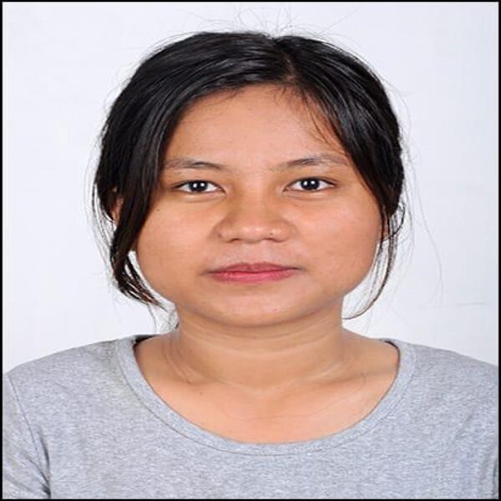

- Personal Information:

Name : Mai Chin Hoi Htem
Current Address : Marwadi University, Rajkot, Gujarat 360003
Contact Number : +918882551802
Email : ameethem170@gmail.com
Gender : Female
DOB : 18/05/1999
Age :25 yrs
Nationality : Myanmar

- Education:

- Basic Education of High School ( Myanmar )
- Matriculation Exam Passed (Myanmar )
- Finished Third Year of B.C.Sc ( Bachelor of Computer Science) In Kalay Computer University, Myanmar.
- Currently studying B.Tech(IT) in Marwadi University, Rajkot, Gujarat, India

- Professional Skills:

- Fast Learners
- Fast Typing Skills
- English 4 Skills ( Upper Intermediate Level )
- Communication Skills
- Problem Solving Skill
- Solid Knowledge in Computer

- Language:

- Burmese Language ( Fluent 100%)
- English ( Fluent 80%)
- Chinese ( 30% )

- Work Experience:

- Domestic Helper in a Chinese Speaking Family for one year
- Part Time Data Entry in Operation Department in Blue Ocean, Yangon, Myanmar for almost one year
- Part Time Cleaner in Yangon Myanmar for one year
- Owner in Mai’s India Myanmar Cargo Service and Money Exchange.
- Current Android Application Trainee at Dotpitch Technologies, Rajkot, India.

- Hobbies:

- Singing
- Fashion Clothing
- Reading Novels and Writing
- Helping for Charity Events
- Sports ( Table Tennis, Football)

