# PERSONAL DETAILS

**Birthdate:** 15th March 1999

**Parents:** Alberto Piquete and Lequeta Meque

**Place of Birth:** Chiloane

**Nationality:** Mozambican

**Marital Status:** Single

**ID Card No.:** 070900989457F

**TIN:** 150231019

**TEACHER, TRANSLATOR AND INTERPRETER**

 L.Piquete L.Piquete

# LANGUAGES

## Portuguese- Fluent

## English-Fluent

## Cindau-Fluent

## Spanish-Basic Knowledge

# ACADEMIC EDUCATION

2016 **Concluded Grade 12**

Beira-***Escola Secundária da Catedral***

2023 **Finalist in stage of Elaboration of Monograph-Degree in English Language Teaching with a minor in Translation** Beira-***Universidade Licungo – Extensão da Beira***

**PROFISSIONAL EXPERIENCE**

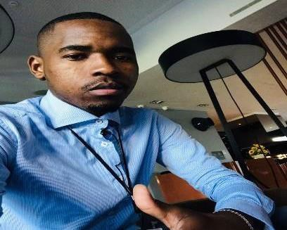

Chipangara-Beira

[luispiquete8@gmail.com](mailto:luispiquete8@gmail.com)

+258 866887935

**Luís Alberto Piquete**

**Barzilay Linguistic Services**

**Internship for 3 months**

Title: English Teacher, Translator and Interpreter

## Barzilay Linguistic Services

## Teacher, Translator and Interpreter

Title: English Teacher, Translator and Interpreter from English to Portuguese and vice-versa.

## Self-employment

**English Private Teacher for 2 years**

**Title: Private Teacher for Adults (For Mozambicans)**

**TELUS International**

Title**:** Portuguese Test Creator for Non-Native Speakers.

# PROFISSIONAL QUALIFICATIOS

# Translation workshop Participation Certificate – Universidade Licungo

**Introduction to Humanitarian Translation Certificate** - Translators Without Borders (TWB) **Management Strategies for People and Resources Certificate** - U.S. Embassy in the United Kingdom

**Strategies for Personal Growth Certificate-** U.S. Embassy in the United Kingdom

**Introduction to Human Rights and the Environment Certificate of Participation**-Unitar

**Técnicas de Comunicação Interpessoal Certificate-**Linkedin

# SKILLS

Good spirit of work and good relationship; Good capacity and easy learning;

High sense of responsibility;

Speed and efficiency in the clearance of activities;

Spirit of initiative and creativity;

Capacity of adaptation;

Dynamism;

Highly Committed;

Well organized.

Good with systems

# REFERENCES

António Barzilai Cuvaca –Barzilay Linguistic Services (BLS)- +258 850371473

Martine de Zoeten-UNDP- martine.dezoeten@un.org

Vanessa dos Santos-Light for the World- +258 82 646 0089

**INTERESTS**

Research,

Languages;

Music,

Sports

Technology