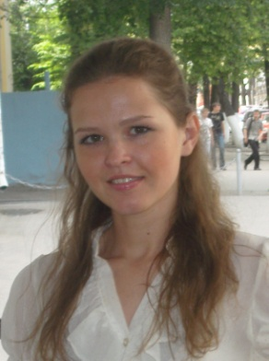
Ksenia Lutsenko
Tel: +7 921 3377190
jobmail8@mail.ru
Personal information:
I am a certified translator. I graduated from the State Linguistic University of Nizhny Novgorod with Master Degree in Linguistics and Intercultural Communications. I have experience in translation in different spheres: business, finance, sport, CV, gaming, video games, legal, certificates, newspaper articles, marketing, medical, patents, scientific, technical, software. I worked with websites and made translations for lighting magazine and translated psychology texts. Besides, I’m adaptable and flexible, well-organized planner and scheduler. I have good organizational and time-management skills.
Education: 2005-2010 The State Linguistic University of Nizhny Novgorod, MSc in Linguistics, Intercultural Communications
Languages: English proficient, Spanish Upper-Intermediate
Experience:
November/2010 - to the present time
Manager, interpreter, “IQ Consultancy”, Saint-Petersburg
Duties: organizing the office layout and maintaining supplies of stationery and equipment; managing filing systems; translating and summarizing material from one language into another; arranging visits with foreign clients and potentially acting as interpreter; organizing meetings, minutes, agendas and travel details for overseas visits; liaising with clients, suppliers and other staff.
09/2008-to the present time
Translator-Freelance
Duties: Written translation from\to English, Spanish.
Areas of expertise:
Advertising
Arts & Entertainment
Banking
Business
Ecology
Economics
Education
Finance
Government
Health
History
Journalism
Philosophy
Sociology
Law
Travel & tourism
Computer skills: Microsoft Office (Word, Excel, PowerPoint, Access), Trados - proficient user.
Hobbies: Learning foreign languages (at the current time I’m studying the Italian language), travelling, photography

