KLING JOHNSON 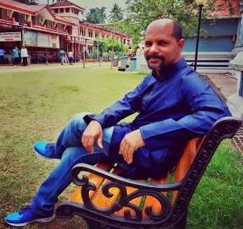
ACTOR/ FILM MAKER/ AUTHOR /DOODLER

Mobile: 0091-9945559289, 082029-23747

E-mail: klingjohnson@gmail.com , klingjohnson@yahoo.com

Languages known: English, Arabic, Hindi, Kannada, Tulu, Tamil, Malayalam, Telgu.

Present profession: Employed as Fire & Patient safety officer at Kasturba Hospital
Manipal (KMC)Udupi

Technical qualification:
  - (B.Tech in Environment KSOU)
  - Diploma in Civil engineering (Board of Technical education-Karnataka)
  - Diploma in Construction management (Annamalai University)
  - Diploma in Industrial safety (Annamalai University)
  - Diploma in Environment and pollution control (NILEM,Chennai)
  - International certification: OSHA,IOSH,NEBOSH, LA 45001

Writing experience
Books written:
- CLI- The Colt - Author (Children adventure fiction)
Published by Notion press- June 2019
Book link: https://notionpress.com/read/cli-the-colt
Awarded Honorable Mention under cultural diversity at
The international Purple dragonfly 2020 book award

- Mari Kudureya Mysooru Kanasu –Original Author credit
CLI- The Colt Translated to Kannada by Dr.Mahabaleshwara Rao
First book to be simultaneously published as paper back and e book by Navakarnataka Prakashana Bengalooru & Mylang - Dec 2020
Book link: https://www.bookbrahma.com/book/mari-kudureya-mysore-kanasu

ENGLISH SUBTITLE PROJECTS:
- Idhu Entha Lokavayya - Kannada feature film -2017
- Mangalore to Goa - Konkani -2019
- Manku bhai Foxy rani - Kannada -2020
- Shakalaka Boom Boom- Tulu -2020
- Nimmellara Aashirvada - Kannada -2021
- Amche Samsaar - Konkani -2021
- Chicken Puliyogre - Kannada -2021
- Dhamaka - Kannada -2021
- Pirkilu- Tulu-2023
- Vasanthi- Kannada 2023
- Dvamdva - Kannada -2023
ALBUM SONGS- ENGLISH SUBTITLE:
- Prabhavah – Kannada song 2020 (Pada music)
- Baby love you- Kannada album song 2022 (Anand audio)
- Psyce Aayene – Tulu-English rap song 2022 (Just roll films)
SHORT FILM SUBTITLE:
- Bali - (Starring -Director- Bhaskar Manipal)
- Akshamya- (Director- Bhaskar Manipal)
- Thote (Made in Kasaragod)- Subtitle (Direction- Gurukiran)
- Koneya Bikshe- (Starring Rons Rodrigues London Direction- Godwin Sparkle)

Kannada feature films scripts written:
1.Paper plane - Writer (A teenage rom com thriller between a boy and a girl based on true events. The religious and family indifference surrounding them forms the plot. The story takes places in a famous Malnad town)

2.Mr. Branthu- Writer (A neo noir thriller based on precognition)

3.Kai Tholdre Kailasa – Writer (The film is about a newly married young couple who seeks periodic medical attention for the lady’s obsessive-compulsive disorder. The daily warmth, humor and perplexing situations the man goes through are based on true events.)

