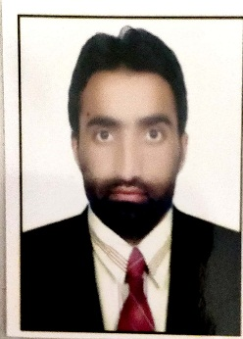
Dr. Khursheed Ahmad
Dar Mohallah Mazbugh Sopore Baramulla, Jammu & Kashmir | M 7006959764
Darkhursheed18@gmail.com Skype: darkhursheedrj5

SUMMARY

To work with a company that appreciates innovation so that I can enhance my knowledge and skills to give my best for the growth of the company. Also to take a challenging and high performance-oriented role in the field of Urban engineering and implement the expertise gained in this field.

SKILLS
- Communication • Computer Skills
- MS Word • English>Urdu Translator
- Office Work • Urdu>English Translator

WORK HISTORY
05/2011 to 06/2019 Army Goodwill Higher Secondary School
Urdu Teacher
01/2013 to Present Date Freelancer Translator + Reviewer
Key Role: Translator: Urdu-English, English-Urdu
(Marketing, Legal domain & Life Sciences experience).

EDUCATION
2003 Secondary School Examination (10th)
Jammu & Kashmir Board of School Education, Kashmir
2005 Higher Secondary School Examination-II (12th)
Jammu & Kashmir Board of School Education, Kashmir
2008 Bachelor of Arts (B.A)
University of Kashmir, Jammu & Kashmir, India
2010 Master of Arts in Urdu (M.A Urdu)
Maulana Azad National Urdu University Hyderabad, India
2012 Bachelor of Education (B.Ed.)
University of Kashmir, Jammu & Kashmir, India
2020 Doctor of Philosophy in Urdu (Ph.D. in Urdu)
Barkatullah University Bhopal, Madhya Pradesh, India

INTERESTS
To understand the organization, to identify its needs and to correlate them with my goals as to apply myself to responsibilities with total devotion, dedication, and dynamism, as to grow along with my organization. I am looking for a job that could provide me a platform from where I can utilize my creativity in order to achieve the goals, which will be assigned to me.

