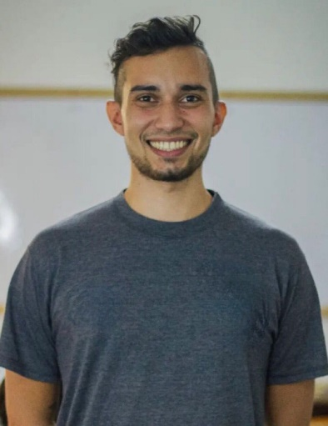
KEVIN FERNANDO MUÑOZ FAJARDO
Translator and Illustrator

Personal Information:
Nationality: Venezuelan
Birthdate: September 17th of 1995
Marital Status: Single
Phone Number: +58 4140321135
Email: kevinfmunoz@hotmail.com
Portfolio: https://www.behance.net/Kevinfmf

Education:

Unidad Educativa YMCA Caracas 2013
Bachelor of Sciences
Universidad de Oriente. Núcleo Nueva Esparta
Hotel Management (Sixth Semester)

Additional Training and Courses:
- Customer Service. Talent Training C.A. Año 2016
- Leadership and Work Team. Talent Training C.A. 2016
- Protocol. Universidad de Oriente. Año 2016
- 5 years of Experience Translating Books from English to Spanish.
- 3 years creating content for Blogs.
- 2 years studying Digital Illustration.

Languages:
Spanish: Mother Language.
English: C1 - Advance Level.
French: B1 - Intermédiaire.

Work Experience:

Kids Jump  Position: English Teacher for Preschool and Primary Schools. |  | Sep 2021 -  Currently
Arknovel.com - @Kevfmf2  Position: Translator and Editor of Web Novels. | Jul 2020-  Jan 2021
Jianlai Limited  Position: Translator of Novels from English to Spanish. |  | Jun 2019 -  May 2020
Freelance Blogger en Steemit.com  Position: Writer and Editor |  | Dec 2017-  Jun 2019
Distribuidora Heralca, F.P.  Position: Merchandising |  | May 2016-  Oct 2017
Recreaciones FlamBeach, C.A  Position: Slot |  | Apr 2017-  Jul 2017
Trattoria Da Federico Restaurante  Position: Waiter |  | Jun 2017-  Oct 2017

