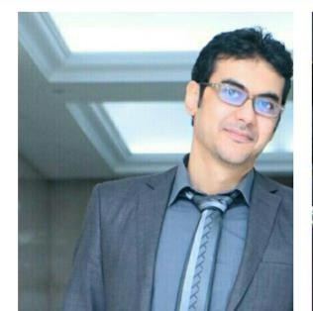

**Karim Zekry**

**I am seeking a challenging career, in a reputable organization in my field of**

**specialization and interest where I can show my abilities**

**Personal Details**

**Address: Lotus – 5th settlement – New cairo**



[**Karim_zekry1989@hotmail.com**](mailto:Karim_zekry1989@hotmail.com)

**01093061707**

Marital Status: Married Date of birth : 28/07/1989

# Key Achievements And Employment History For 7 Years

* **Translator for one of the biggest stock market companies in the world**
* **Freelance translator for above 100 projects in different fields**

# Education

* + **Faculty of Engineering 10th of Ramadan university**
  + **Major : Communication**

**Languages : Arabic , English -- fluent writing and speaking –**

**Courses : 1- ICDL 2- English courses (British council)**

1. **Photoshop**
2. **Facebook campaigns**
3. **Editing**