MS.KALPANA SINHA(KAJAL) 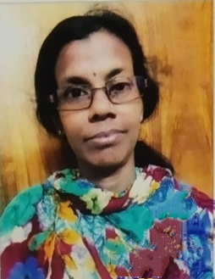
(kalpanasinha644@gmail.com)
C/o.Narayan Dash,( Infront of Guru Patnaik Residence)
At.Allei Temple Lane,Via.Bada Odia Math,Baseli Sahi, Puri.752001.Odisha.India.
91-8249569299(M).
To grow with through the application of hard work, dedication, integrity and sincerity.
WORK EXPERIENCE: TOTAL ONE AND HALF YEARS OF TRANSLATIONS (JANUARY,2021 TO TILL CONTINUING)HAVING COMPUTER KNOWLEDGE.

EDUCATION:
B.A.(BACHELOR OF ARTS GEGREE UNDER UTKAL UNIVERSITY VANI VIHAR BHUBANESWAR,ODISHA.
CIVIL STATISTICS:
Father's Name :Late Rabindranath Sinha,
At/Po.Bantaligram,PS.Gop,Dist.Puri.752002.Odisha.
Date of Birth: 1st April 1967.
Gender: Female
Nationality: Indian
Linguistic Ability: English, Oriya, Bengali, Hindi etc..
Subjects in Education: English, Oriya, Hindi, Bengali, Economics, History, Geography, Social Science,Food and Nutrition (Cooking), General Science, Sanskrit etc.....

Place: Puri. ( KALPANA SINHA )
Date:

