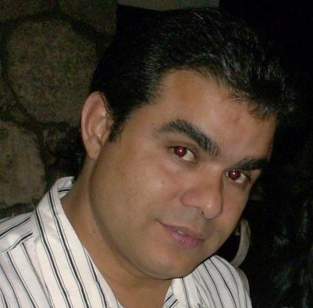 |  | José Iván Fuentes Fiallo  english to spanish translator and subtitler
professional summary  Long before I wrote and discussed my graduate thesis as an Engineer on Electronics fully in English back in 1993, I knew working as a linguist was something I would eventually turn to.  My ever-latent love for languages, appetite for knowledge and communications skills prompted me to start a career as a freelance translator in 2013.  I provide my clients with crafted translations of complex technical and scientific texts. My service includes translations in many other fields as well. They also can benefit from my expertise in facilitating communication between Spanish and English-language speakers.  tools  Microsoft Office Suite  SDL Trados  Aegisub  Atlas  Subtitle Workshop  Subtitle Edit  OmegaT  Photoshop  Contact  (+53)53 103335  waseperry13@gmail.com  My links |  | Skill highlights  - Translation / Interpretation / Subtitling  - Technical writing / Formatting expertise  - IT-level computer skills  - Customer service / Active Listening and Communication  - Teamwork / Cultural competence  RELEVANT EXPERIENCE  English to Spanish translator / Freelancer  2013-present  - Translation of technical documents on Electrical & Electronics engineering such as service manuals, datasheets, abstracts, handbooks. I can use CAT tools whenever requested. I am a current member of Day Translations, Inc. staff of online translators and I am also doing subtitling in Rev.com and Flitto.com.  - Translation of marketing, journalism, business, medical and product related documents in a rate of up to 3000 words a day. I really enjoy translating baseball and rock music texts.  - Facilitating communication with English speaking Chinese engineers and technicians at Photovoltaic power stations.  PC Technical Assistance “A” Specialist / Copextel, S.A.  2000-present  - Customer service in PC related issues. Troubleshooting, repairing and maintenance of PCs, laptops, printers and other peripherals.  Education & TRAINING  University of Pinar del Río, Cuba  1988 - 1993  Bachelor of Engineering (B.Eng.) on Electronics (GPA – 4.1)  Language School "Andrés Bello", Pinar del Río  1991 - 1993  English as a Second Language – Level Four  Postgraduate Coursework  Advanced Technical English, 1994; Translation and Culture, 2003; Translators and Today´s Globalization, 2012; Introduction to Humanitarian Translation, 2018; Translation as a Career, 2019.  volunteer work  Currently collaborating with Translators Without Borders (7.5k plus translated words)
Note: More information can be provided upon request, such as references or additional work history.

