**João Vasco: Curriculum Vitae**

**2019**

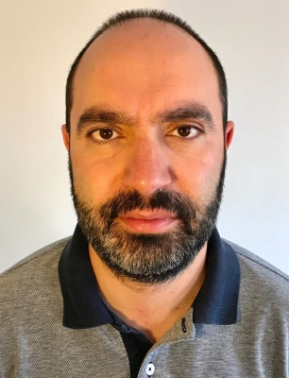

Name: João Vasco

Age: 39 years

Location: Lisbon, Portugal

Telephone number: (+351) 961316995

Email address: joaovasco.jv@gmail.com

**Career history**

* **March 2016** → Portuguese Translator and Proofreader (Areas: Movies/TV Series) EN/PT – ZOO Digital (freelancer)
* **January 2015 until December 2017** - Portuguese Translator and Proofreader (Areas: Movies/TV Series) EN/PT – Deluxe Digital Studios (freelancer)
* **December 2005** → Politics and economics reporter at Antena 1 – Portuguese national radio;
* **April 2013 until December 2015** - Economics reporter at Antena 1 – Portuguese national radio;
* **June 2012 until March 2013** - Desks reporter at Antena 1 – Portuguese national radio;
* **December 2005 until May 2012** - Sports reporter at Antena 1 – Portuguese national radio;
* **Jan 2005 until June 2005 -** Sports editor at RUC – Rádio Universidade de Coimbra;
* **Mai 2003 until June 2005** - News editor and reporter at RUC – Rádio Universidade de Coimbra;
* **Fev 2004 until Fev 2005** – Administrator at RUC – Rádio Universidade de Coimbra;
* **December 2001 until June 2005** – News editor and reporter at Jornal Universitário de Coimbra – A Cabra;
* **September 2002 until May 2005** – Entertainment and arts editor at Jornal Universitário de Coimbra – A Cabra;

**Education**

* **October 2006 until January 2007** - **Intensive English Course | Level C1-C1.1** – ILNOVA, Lisbon | Portugal
* **October 2001 to July 2005** – Journalism licentiate degree - Faculdade de Letras da Universidade de Coimbra
* **October 2013 until December 2013** – Portuguese Proofreading Course / Levels I and II – Escrever Escrever, Lisbon | Portugal

**Languages**

* Portuguese- writing / speaking / reading– Native level
* English- writing / speaking / reading– Proficient User