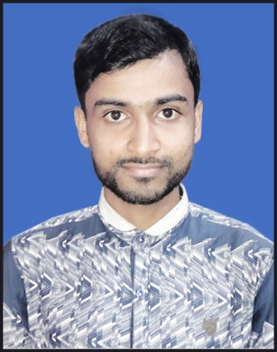
Resume Of
Jewel Mia
C/O: Habibur Rahman
Mailing Address: Atharabari, Ishwarganj. Mymensingh
Mobile No: 01931649233
Email: newelljewell730@gmail.com
CAREER OBJECTIVE

Being an enthusiastic new comer in the area of Civil Engineering, I am aspiring to be a dynamic engineer. As a young aspirant, I want to pursue my goal with absolute dedication, sincerity, honesty and perseverance.
EDUCATIONAL QUALIFICATION

- Diploma in Civil Technology
Institute : Mymensingh Polytechnic Institute.
Result : (2.96 Out of 4)
Session : 2013-14
Board : BTEB
- Secondary School Certificate (S.S.C.)
Institute : Atharabari M. C. High School
Result : GPA: 4.19 (out of 5.00)
Group : Science
Passing Year : 2013
Board : Dhaka Board
PROFESSIONAL TRAININGS

- The Industrial Attachment Training Program.
Institute : Public workers development (P.W.D)
Address : Gazipur, Bangladesh.
Course Duration : 3 Months.
Others skill : Plumbing & pipe fittings. TTC Mymensingh under BTEB
: Auto Cad 2d & 3d with Max
JOB RESPONSIBILITY:

- Estimating All Materials Of Any Building Construction.
- Design of Building Construction.
- Flow up Constructions Management.
- Building Plan.
- Consulting Of Constructions Farm.
- Survey of Lend.
- Auto-cad 2D & 3D.
- Transportation Engineering (Hi-Way & Rail-Way)
LANGUAGE

- Bengal : Standard in reading, Writing and Speaking
- English : Standard in reading, Writing and Speaking
CONTUCT ADDRESS
GYJLKJ
PRESENT & PERMANENT
Jewel Mia
Bisnopur, Atharabari,
Ishwarganj, Mymensingh
PERSONAL FROFILE

- Name : Jewel Mia
- Father : Habibur Rahman
- Mother : Aungura Begum
- Date if Birth : 17/07/1997
- Birth Place : Bisnopur, Mymensingh.
- Religion : Islam
- Height : 5 ft-6 inchs
- Weight : 50 kg
- Nationality : Bangladeshi (By Birth)
- Sex : Male
- Blood Group : O(+)
- Marital Status : Unmarried
REFERENCES
Engr. Jamshedul Alam
Instructor
Mymensingh Polytechnic Institute.
Mymensingh.
Mob :01712-991323

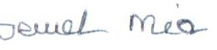
I hereby declare that the above written particulars are true to the best of my knowledge and belief.

Jewel Mia)
Date:

