Profile of Jaydeep Mukherjee
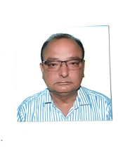
Jaydeep Mukherjee is a Certified Engineer with Computer Science and Statistical Methods as the major subjects. He has a total experience of 35 years out of which he has more than 6 years in translating Danish, Spanish and Dutch documents to English. He has also worked in translating Bengali and Italian documents to English. His main customer was IBM India Ltd among others. The documents involved Information Technology system design and system implementation and also included technical specifications and business processes. The volume of work involved delivery of more than 6000 pages on time with high quality. Jaydeep also has the experience of translating English documents to English and Bengali, and handling translation of Bengali documents to Bengali.

