Name: Ivy Chi
Contact: 86+15013014157
Email: ivychimedtrans@qq.com
ICH GCP Certificate Holder

I offer:
MTPE, Translation, and Proofreading
I work with:
Transperfect, PPD translation,
IQVIA translation team,
Alocad Group,
CCJK/Mars Translation,
CBG Translation
Strong Fields:
Life Science
CAT Tools:
SDL Trados Studio 2019,
Memsource, Memoq, Wordfast, Transtool, Wordbee
Certificates:
CATTI Level 3; TEM 8
End Clients:
IQVIA, Pfizer, Biogen, Momentive, DMG, Takeda, Q2 Solutions, Novartis, Regen, etc.
Education

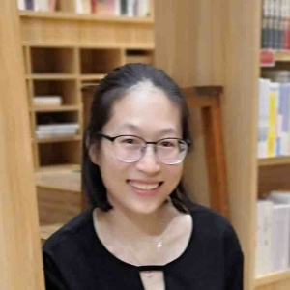
2008-2012 Heilongjiang University, Major in English Linguistic and Literature;

2004-2008 Yong’an No.1 High School.

Project Review (English <> Traditional & Simplified CN)

Pharmacovigilance:
Translation and Proofreading, concerning SAE, safety report,
case report, adverse reactions (total volume: 1,000,000 words and ongoing)

Medical Devices:
Translation, concerning PEG tube, Epipen, PTA Catheter, Temperature management system, Acumed bone plates, Advanix Pancreatic stent, automated external defibrillator (total volume: appr. 200,000 words)

Dossier and others:
EC review documents, safety report updates, informed consent forms, prescribing information, market registration, new drug submission, high-efficiency HPLC analysis
Dental implantation materials and 3D printing, COVID-19 related translation and medical journal article translation
(Total volume: appr. 1,000,000 words)

UI translation:
Manual translation: MixStar-eMotion, AutoMix-Dispenser, Xenois xLung kit; Dyson People Employee User guide, EGG devices (Total volumes: appr. 100,000 words)

