Iryna Kyrychenko
Translator and proofreader
7 years of experience
Languages
English — С1
Ukrainian — C2
Russian — C2
Tools
Trados
SmartCAT
MemoQ
Adobe Acrobat DC
MS Office
Contacts
irenegongzuo@gmail.com
+38 (063) 787 72 61

Personal Profile
I am a professional translator and proofreader of English, Ukrainian & Russian languages with over 7 years of experience. My biggest clients include the "MSI Ukraine" hardware company, "Novyi" TV channel, "SayHi" internet media, "Nike", "Nestle", "Amway", "YouTube" among the others.
Fields: legal, medical, marketing, technical, literary, media and art.
My main priority is to ensure an accurate and high-quality translation that will be easy to understand for the end reader.

Experience
English-Russian/Ukrainian translator for MSI Ukraine (major hardware company)
Oct 2020 - Nov 2023
Translations of technical documentation, instructions, user interface texts, safety instruction guides, product manuals, and agreements.
English-Russian proofreader at “Say-hi” (The most popular media about arts and technology among the Ukrainian-speaking audience.)
May 2018 - Aug 2020
Proofreading articles about UI/UX design, audio/video/photo editing programs, illustration, motion graphics, digital, programming, business, and technology.
Freelance English-Russian/Ukrainian translator (ProZ.com, TranslatorsCafé, UpWork, Weblancer)
Apr 2016 – Present
Translations in different specializations include legal documents, medical instructions, books, advertisements, etc.

Education
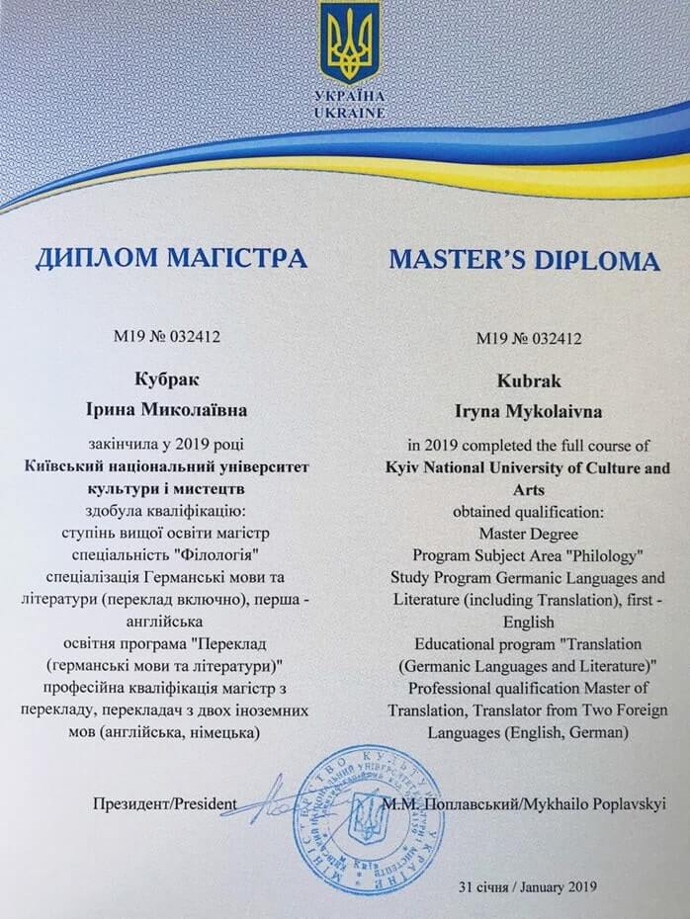
Kyiv National University of Culture and Arts
Master's Degree in Translation Studies: English, Ukrainian and Russian languages
2013 – 2019, Ukraine

