Detail-oriented Statistical Analyst with 10 years of Central Bank of Iran experience. Coordinates multiple
concurrent projects efficiently. Known for strengths in data processing and Excel reports.
Well-organized Statistical Analyst with sound knowledge of statistical modeling techniques and methodologies. Experience using statistical packages for analyzing datasets, including SPSS and Microsoft office. Adept at report writing and presenting findings.

Skills

Data analysis

Data profiling

Proficient in [Excel. word, PowerPoint. windows]
Price Index (Certificate of Deutsche Bundesbank Eurosystem. Frankfurt Nov. 2017)

Work History

Very Good

Very Good

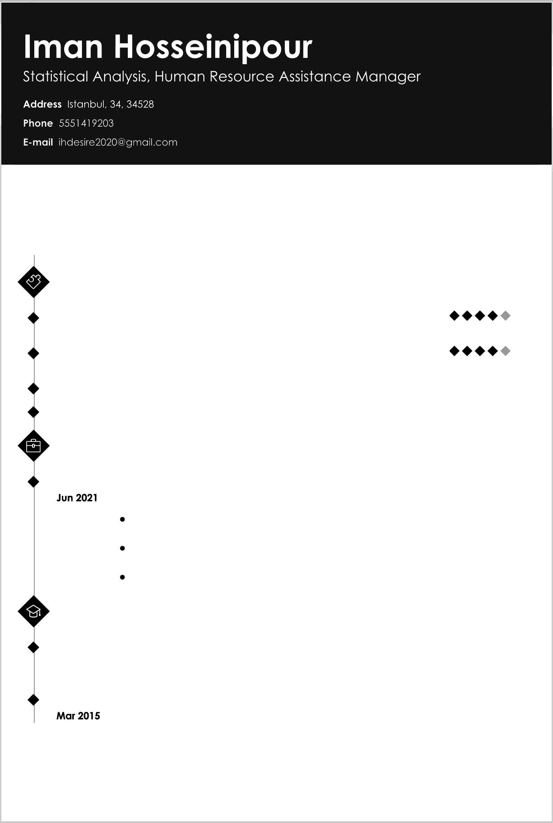

Feb 2002 - Statistical Analyst

Central Bank of Iran. Tehran. Tehran
Prepared statistical analysis plans and provided statistical interpretation for
graphs. tables and charts.
Manipulated, transformed and analyzed data by reviewing computer reports,
printouts and performance indicators.
Acquired data from primary or secondary data sources.

Education

Jan 2012 - Master in Public Administration: Human Resources
Jun 2015 Management Statistics
University of Tehran - Tehran, Iran
Feb 2015 - Certificate: Microsoft ICDL
IRANICDL.ir - Tehran, Iran

