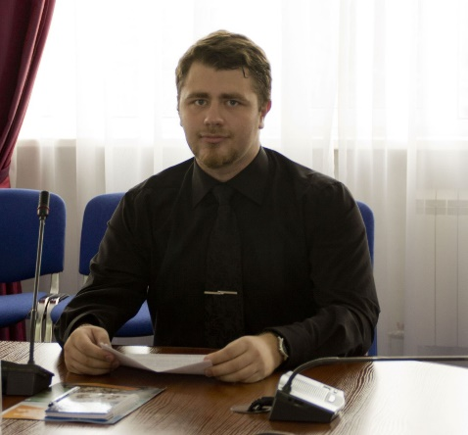
Ilya Kositsyn
Ilya6392@gmail.com +79098155360 Blagoveshchensk, Russia
Professional profile
Russian-English-French translator with 4+ years of flawless experience.
Experienced in software for presentations, video and photo-editing
Proficient in international relation, business and politics
Professional Experience
GO-English language school, Blagoveshchensk, Russia
Senior teacher Oct 2015 - present
- Give individual and group English lessons
- Translate documentation
- Develop Study program
Dr. Lecter language center, Blagoveshchensk, Russia
Owner, teacher, translator, Feb 2015 – Oct 2015
- Manage small individual business
- Develop marketing strategy, company image, etc.
- Private English and French lessons
- Commercial translation of different kind
Eurosoba Inc., Moscow, Russia
Sales dpt. Executive, June 2014 – Feb 2015
- Manage sales department, using CRM, team building techniques, etc.
- Transact affairs with international counterparts
- Prepare documentation and reports, using different software
SK MOST, Moscow, Russia
PR-manager in Blagoveshchensk, June 2013 – June 2014
- Organize and conduct press-conferences
- Prepare presentations, using different multimedia software
- Create brochures, leaflets and other printed materials
- Edit promo videos using proper software
Education
Amur State Pedagogical University (2014 – 2016)
Magister of History
Amur State University (2010 – 2014)
Bachelor of International Relations. Major – American studies.
Additional skills
- Proficient PC user
- Participant of NATO-Russia student exchange program
- Good amount of published articles concerning history and international relations
- Wide knowledge in different fields
- Common sense

