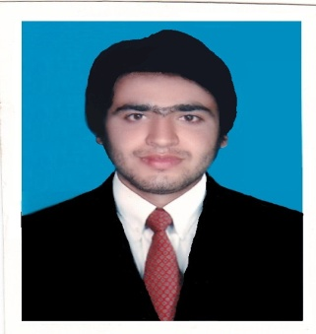
Syed IbrarHaider
Father Name: Syed ZawarHaider
Ibrarmoiz5@gmail.com
Cell # 0092-332-004-616-5
D.O.B: 26-10-1989

Objective

My immediate goal is to be a part of a dynamic organization and effectively put to use my experiences and in effectively helping the organization achieves its desired results .A responsible person who is hard working, communicative with team members and shows a friendly attitude towards the success of the assigned jobs.
Working Experience

Post | Organization | Duration | Key Responsibilities
Assistant Accountant. | M.M STEEL private Limited. | November 2012  -  December 2014 | Performed accounts payable functions for construction expenses.  Managed vendor accounts, generating weekly affair,  Managed financial departments with responsibility for Forecasting, Payroll, Accounts Payable and Receivable.  Created budgets and forecasts for the management group.  Ensured compliance with accounting deadlines.  Prepared company accounts and tax returns for audit.  Coordinated monthly payroll functions for 200+Employee
Teller | Ravi Exchange Company (PVT) Limited PAK | Dec 2015 –  March 2016 | Process Routine account transaction, Open accounts, Help customers fill out deposit and withdrawal slips, Disburse money to customers, Assist customers at the drive-through window, Record all transaction, Exchange foreign currency.
Home Remittance Officer | Punjab Provincial Co-operative Bank | April 2016 –  Present | Process Routine account transaction, Help customers fill out deposit and withdrawal slips, Disburse money to customers, Assist customers at the drive-through window, Record all transaction, Pay out Voucher E-Business.

Education

Year | Degree | Institute | Board/University | Grade/Division
2012 | B.com | Image Group of collages | Punjab University | 2nd
2010 | I.com | Govt Degree collage | Bise Gujranwala | 2nd
2008 | Metric | Govt High School | Bise Gujranwala | C

Computer Skills

MS- Office, (MS – Word, Excel, Access, Power Point) & Internet Browsing,
ITC technologies (related software, phone fax email, the internet)
Accounting Software: - Tally 7.2, Peachtree Quantum 2010, Quick Books,
Tying Speed 100/50 W.P.M

Diploma & Certificates

Accounting Professional Software 3 Month Diploma.
Computer Operator Certificate from Pakistan Institute of computer science.

Hobbies & Interests
Cricket
Visiting Different Firm or Historic Place
Reading Islamic Books
Searching on different topic

Reference

Available on request

