H. Kim Ellis
11-108 Unak Cheonggye-ro 490 beon-gil,
Ha-myeon, Gapyeonggoon,
Gyeonggi-do, 12432 Korea
(82) 010-9949-3605
intlaffr@hotmail.com

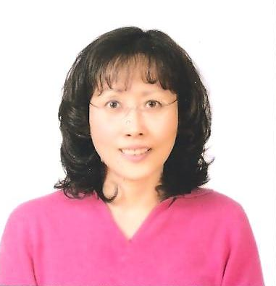

Objective:

To obtain a position as an English teacher where I can utilize my knowledge and experience in teaching English conversation, reading, listening, and writing or English interpretation or translation to Korean students.

Education:

2008 – 2012 Master of Arts - Teaching English as a Second Language
Andrews University, Berrien Springs, MI U.S.A.
1992 – 1994 Bachelor of Arts - Business Administration Emphasis in Accounting
Union College, Lincoln, NE U.S.A.
1989 – 1992 Associate Degree - Health Science
Union College, Lincoln, NE USA

Work Experience:

2012 – Retired Sahmyook University, Seoul, Korea
Sahmyook University – English professor at Sahmyook University English Department teaching various disciplines in English such as vocabulary, grammar, listening, writing, presenting, translating, interpreting, and Biblical literature.

1994 – 2012 SDA Education, Seoul, Korea

SDA Education – Duties include teaching Bible and doctrinal beliefs of Seventh-day Adventist Church as a missionary, teaching English to Korean students according to the institute’s textbooks and curriculum, preparing students for OPIc examinations, leading out interpretation and translation class with instructions on how to apply proper grammar usage, visiting and teaching junior classes, planning curriculum and teaching elite classes, and instructing and encouraging students to improve pronunciation, grammar drills, and conversation skills.
Served as a coordinator at Seoul Main Institute for a year overseeing over 20 foreign teachers.
Worked as a communication coordinator for 15 years at the International Affairs department, assisted with interviews and recruitments of the new English teachers, made recruitment advertisements for SDA Education in magazines in the USA, Australia, and England, paid out liability payments to former teachers for SDA Education, translated business documents and sermons from Korean to English, and many other responsibilities.
I have good rapport with my students.

1982 – 1989 Israel Discount Bank of New York, New York, NY U.S.A.

Israel Discount Bank of New York – Began as a commercial teller dealing with clients’ banking needs. Was promoted after a year to be a supervisor of the Paying and Receiving Department. Duties involved transferring funds all over the world using telegraphs and S.W.I.F.T., overseeing high pressured office dealing with hundreds of million dollars in overseas funds and Federal Reserve Bank funds transfers making sure of its accuracy.
Later, was promoted to be a bank officer authorizing funds. The title held was Authorized Signature.

1977 – 1982 Norstar Bank (Formerly Oneida National Bank) Utica, NY U.S.A.

Oneida National Bank – Operated a keypunch machine and kept records of time and demand loans, worked as a commercial teller, afterwards was promoted to all purpose and collection teller carrying out many responsibilities related to collections, stocks and bonds clearing and purchasing, interest payments, and general banking process.

1975 – 1977 Smith Distributors, Incorporation New York Mills, NY U.S.A.

Smith Distributors, Inc. – Worked as an accounts receivable clerk for two years. Posting invoices, credits, and payments. Prepared bank deposits, kept customer files, and took monthly balance proof with accuracy.

Others:

- Graduated with the highest honors and was on the Dean’s list in undergraduate school
- Translated or interpreted over 1800 hours at SDA Education
- Received the best missionary of the year award from the Korean Union Conference during the centennial celebration
- Published an article each month for 12 months for Signs of the Times Magazine
- Volunteered in India, Mexico, and Dominican Republic with the Maranatha group in overseas building projects
- Organized and joined mission trips to the Philippines, Mongolia, Thailand, and Cambodia with SDA Education
- Have traveled extensively to various countries including the holy land tour with the Sahmyook University theology department
- Voluntarily have been preparing and conducting weekly Bible classes in SDA Education since 1994
- Translated bulletins, programs, and many other things
- Served and helped students for many years
- Lend hands wherever there is a need
- Public speaking in numerous places, including Yeon Sei University OPIc presentation

