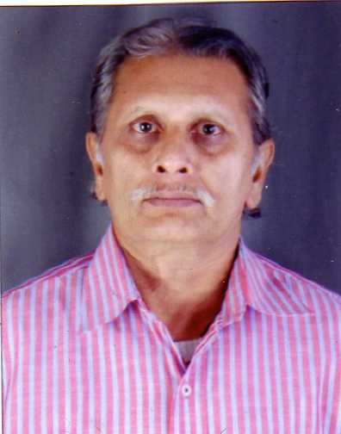Himatbhai H ParmarYadunandan BuildingSakhianagar-2Air Port Road, RAJKOT 360 007parmarhimatbhai@yahoo.com

BIO DATA
Name of post applied Executive Secretary
Name& Address HIMATBHAI H. PARMAR
Sakhianagar-2
Air Port Road
RAJKOT 360 007
parmarhimatbhai@yahoo.com
099245 76998
Age 57 years
Educational & other Qua. 1.B.com
2 Dip. In Journalism(result abaited)
3.Certificate Course in Computer operating
4 Certificate course in FoxPro
5 Knowing internet & e-mail
Experience Total 30 years as under
Name of Organization Post Held Year
Netra Raksha CharitableTrust Clerk 1975-1980
Private Oraganisations Stenotypist 1980-1983
Guj.Ind.Investment Corpo. Stenographer Grade-I 1984-2000
Raghuvanshi Charitable Trust Liaison Officer During 2001
Rehabilitation of the
earthquake affected
in kutch
Export Knowing procedure
Excise Knowing procedure
Project Finance knowing procedure and project report
NGO work knowing livelyhood project and Micro Finance concept
Presently Running a Tiny Project Advisory services and
Also an NGO
Himatbhai Parmar
99245 76998

