CURRICULUM VITAE

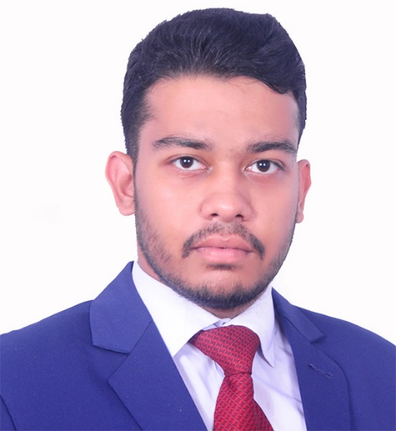
Personal Information:
Name : Hasanul Hoq
Father’s Name : Dr. A.K.M Masudul Hoq
Mother’s Name : Sirajam Monira
Present Address : Shingtola,Luxmibazar, Dhaka.
Permanent Address : Chand Monjil, Munshipara, Dinajpur.
Cell : +8801773449673
Email : shoummo1971@gmail.com
Date Of Birth : 05.12.1999
Sex : Male
Height : 5’7”
Marital Status : Married
Nationality : Bangladeshi
Education :

Degree | Department | Name Of Institute | Board | Year | Result(GPA/CGPA)
S.S.C | Humanities | Dinajpur Zilla School | Dinajpur | 2014 | 5.00 out of 5.00
H.S.C | Humanities | Dinajpur Govt. College | Dinajpur | 2017 | 4.33 out of 5.00
B.A(Running) | English Literature & Language | Jagannath University |  | 4th year | 3.30 out of 4.00

Extra Skills and Co-Curricular Activities :
1.Good command over both Bangla and English language(speaking, listening, reading and writing).

2.Translator- English to Bengali language and vice versa. I have more than 4 years of translating experience. I have completed a good number of translating projects. I have translated 24,000 worded study guide within 3 days which was associated with British Council and funded by UNDP. I have got the opportunity to translate articles of Professor A.A.M.S Arefin Siddique, former Vice Chancellor, Dhaka University. Besides, I have done the translation works of officials like Police Officer’s as well. In a word, Translation is my passion.
Translated Books, Poem Books with proofreading.

3. Writer (love to write short stories, poem etc.)

4. Editor (Working as a Co-editor in an E-zine named The Scribbler)

5. Independent Film Maker (Awarded as Champion, Global Impact Segment in the Girls impact the world film festival,2019, Austin,Texas,U.S.A with his short film “In Search Of Rekha Hasda” and got invitation to attend the festival and Red Carpet Ceremony in April 2019,U.S.A).

11. Former film screening Ambassador of the NGO named ConnectHer, Texas, USA.
12. Basic Computer operating expert.

Loves To Do:
1.Translate
2.Research
3.Read books.
4.Write.
5.Film Making.

Date:06/09/2022
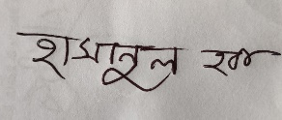
Signature

