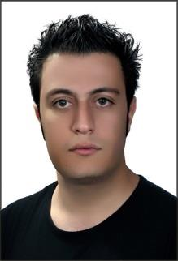

Mobile:+989211079630 Email:hani.mrzbn@gmail.com

Born on:31/1/1990

Objectives
To join a team that are hard work for success with no matter of time, position and salary we will be a strong team of members together, this is the first and last objective(s) of mine, “Advance together, Success forever”, I wish.

Skills
HTML(HTML4,5)
CSS(CSS2,3)
Java Script
ASP.net(C#)
Ajax(Microsoft Ajax Toolkit),Java
C#.net
Visual Basic 6.0
SQL Server
Android application programming (B4A) and too strong in solve algorithm problems.
Microsoft Office
Adobe Photoshop
Windows Server, Unix, Windows XP, Windows 7, Windows 8, windows 8.1 Active directory.
Install LAN networks, Maintain ‘em and support computers and maintain ‘em such as hardware or software items.
Translation of mobile and computer applications and texts into Farsi from English or reverse of it.

English Fluency
Speaking: Very Good
Listening: Very Good
Writing: Very Good
Reading: Very Good
Education
B.Sc. IT Student - University of applied science & technology
Portfolios:
Online game support:
Worked remotely as a live online game support by live chat and forum of the LuckyBit online game company (http://luckyb.it) for about 1.5 years.
Desktop application portfolio (C#):
http://www.smartautoruncleaner.com, an antivirus that is special for Autorun-malwares. Visit the website and download antivirus. Note: If website was down, you can search software on search-engines like google.com
Web portfolio:
http://pgdec.co Parsian Ground Data Explorers Company.
http://www.arya-gostar.ir (Developing at the moment, will be available soon)
Mobile application translation portfolio:
Translation of Hive (online Bitcoin wallet mobile application). See the below link:
https://bitcointalk.org/index.php?topic=620798.msg7028587#msg7028587
Teaching computer courses:
Teaching computer programming courses such as algorithms, C#, Visual Basic 6.0, android programming, web designing and programming and ICDL courses at the Arya Gostar computer training center.
http://www.arya-gostar.ir
Interests: Eager and thirst to learn more, more & more to achieve bigger targets more than ever.
References: References are available on request.

