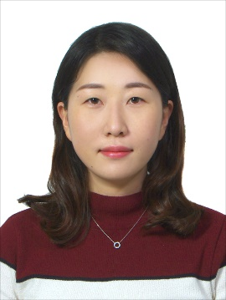 | HanEum Jung  Republic of Korea  Phone: +82 10 2002 0227  E-mail: haneum.jung@gmail.com  Skype: haneum.jung@hotmail.com
WORKING LANGUAGES | English to Korean
SKILLS PROFILE | - Excellent working knowledge using Microsoft Office software  - Knowledge of and experience  - Good filing and organizational skills  - Experience in handling confidential paperwork  - Ability to take accurate phone messages and deliver messages promptly  - Good customer-relations background

EXPERIENCE
Feb. 2018 — Present | Freelance Translator (English to Korean)
- NewYork State Education booklet for disable students
- Windows 10 Manual Video, presentation and description translation
- Mobile application translation & proofreading
- ‘Pet’s Diary’ Mobile application description, text on screenshots, advertisement text, keywords and common & specific pharases
- ‘LightX’ Mobile application decription, advertisement text, keywords and pharases
- Product description translation
- Product description and marketing, Castellex Air500 air filtration system
- Working on “Amazon project” to describe and translate product headline, description
- Certificate of Deposit
- Translate Korean Certificate of Deposit from Korean bank into English to help client understand related document
- TED.com translator member
- ‘The history of human emotions’ by Tiffany Watt Smith
- ‘3 thoughtful ways to conserve water’ by Lana Mazahreh
- ‘The brain benefits of deep sleep – and how to get more of it’ by Dan Gartenberg
- ‘Soundscapes’ by Peter Gregson in TEDxAlcatraz
- ‘The business benefits of doing good’ by Wendy Woods in TEDTalks
- ‘Cannibalism in the animal kingdom – Bill Schutt’ by Bill Schutt in TED-Ed
- ‘Music as a key to understanding reality’ by Bijan Khadem-Missagh in TEDxBratislava
- ‘A printable, flexible, organic solar cell’ by Hannah Bürckstümmer in TEDTalks
- ‘How the hyperlink changed everything’ by Margaret Gould Stewart in TEDTalks
July 2014 —  September 2017 | Quality Control  Janssen Korea (Pharmaceutical company)  - Translating English to Korean  - Pharmaceutical regulation documents for using on site (Standard Operation Procedures, Work Instructions, etc.)  - Technical experimental documents (Test methods, USP, etc.)  - Laboratory papers, tables and tests results prior to well treatment  - Preparing/issuing English documents  - Technical documents for experimental results as reports  - Updating reports and other technical documents  - Clarification letter for importing chemicals  - Equipment operating procedure manual  - Global audit and follow up  - Transcribing English to Korean  - Update current status during global audit  - Communicating by email with global branch  - Participating global business trip to get method transfer in test method for new products as project representatives.
EDUCATION | - Major: Chemistry in bachelor’s degree
AREAS OF EXPERTISE | - Technical/Industry/Engineering  - Pharmacy/Medical  - General texts
SOFTWARE | - MS Office  - Adobe Acrobat  - SDL Trados 2017

