Hala AlRoumani  +963933222125  Mazzeh Highway – AlMontazah Building 5th floor – Damascus, Syria  halaroumani@gmail.com | 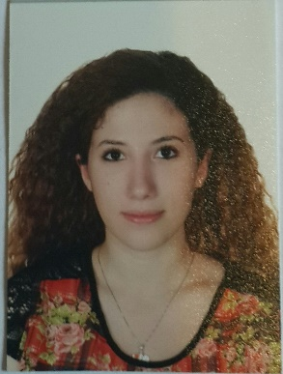

Objectives
After taking a few steps into the world of employment, I am an ambitious employee with a thirst to prove myself in search of a full-time job to put my experience and skills in action as a linguist and translator.
Education

29/06/2012 | Attestation of The General Certificate of Secondary Education - Literary Section -
- Little Village School

08/06/2016 | Bachelor’s Degree in Translation and Interpretation
- Lebanese International University – Beirut, Lebanon –
- GPA 3.10/4.00
- 3 years of experience in translation of different subjects (Legal, Economic, Literary, Scientific, Technical, Journalistic, UN Documents, Medical)
- 1 year of experience in interpretation of all kinds (Simultaneous, Consecutive, Onsight)
- Profound success in my senior project (وعبرت العبرية إلى العربية) that won first prize on all LIU campuses.
Experience

20/06/2016 - Present | Online Translator (Volunteer)
United Nations Development Program – Geneva, Switzerland
- Translator/Proofreader/Editor of UN related subjects, articles, and speeches.

24/07/2016 – 14/08/2016 | Translator (Internship)
Syria Trust for Development (Syrian Handicrafts Ltd.) – Damascus, Syria

- Admin of the company’s website and linguistic supervisor (Arabic, English, French).
- Translator and proofreader for brochures, slideshows, and other articles (Arabic, English).

16/08/2016 – Present | Dubbing Translator
United Company – Damascus, Syria

- Translation and proofreading of subtitles (English, Arabic)
Skills
- Proficient in Arabic and English
- Fluent in French
- Computer proficient [ Microsoft Office {Word – Excel – PowerPoint} – Subtitling Program {Subtitle Edit} ]

Traits
- Issue resolver
- Fast learner and adapter
- Collaborative team member
- Sharp communication and life skills
- Energetic
- Organized
- Multitasker
- Productive under pressure

Diplomas
- Internet Based TOEFL 99/120
- SAT 1875/2400
- DELF B1 71/100

Hobbies
- Horseback Riding
- Hiking
- Traveling
- Reading

