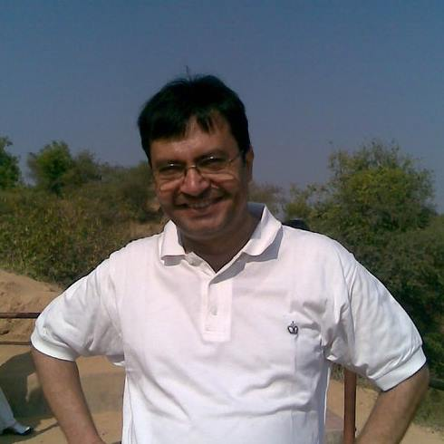
CURRICULUM VITAE

Name: GIRISH TARWANI

- Address: A – 301 Neelkanth – II Apartment,
Near Sahajanand Residency,
Opp. Gujarat University Ground,
Drive In Road, Ahmedabad – 380 009 Gujarat

- Phone: Mobile: 99042 11999 / 94293 64590

- Email: girishtarwani@gmail.com; girishtarwani@yahoo.co.in;

- Educational Qualifications:

EXAM PASSED | UNIVERSITY | CLASS OBTAINED
B. Com. (Hons.) | The M.S. University of Baroda | SECOND
PG Dip. in Human Resource Development (HRD) | The M.S. University of Baroda | FIRST
PG Dip. in Industrial Relations & Personnel Management (IRPM) | The M.S. University of Baroda | GRADE -B
LL.B. with Labour Laws | The M.S. University of Baroda | SECOND
LL.B. (Special) | The M.S. University of Baroda | SECOND
PG Diploma in Marketing Management | Gujarat University (B.K. SCHOOL OF MANAGEMENT, Ahmedabad) | A--

- Past Experience:

I have worked in past in HR function with various organizations and at different levels. I have worked for below mentioned Indian as well as multinational organizations:

- Troikaa Pharmaceuticals Limited, Ahmedabad
- Oswal Industries Limited, Kalol, Gandhinagar
- Jyoti Ltd., Baroda.
- SCHOTT Glass India Pvt. Ltd., Baroda.
- Sterling Addlife India Ltd., Ahmedabad (Sterling Hospitals chain).
- K. A. Malle Pharmaceuticals Ltd., Ankleshwar, Dist. Bhrauch, Gujarat.

- Experience as Translator:

I am offering translation services as a freelance translator. I translate from English to Gujarati language and from Gujarati to English, from English to Hindi and Hindi to English, and from Hindi to Gujarati and Gujarati to Hindi language as I possess sound command of all three languages.

In addition, I have been providing translation services for the law magazine “Gujarat Law Herald” published by Bar Council of Gujarat, Ahmedabad as and when required by them.

Apart from this, I work as a freelance translator and provide translation services for various legal documents and pleadings.

- References:

- Mr. Nilesh Panchal
Gujarat Law Herald,
Bar Council of Gujarat,
Opp. Gujarat High Court, Ahmedabad.
Phone: 079-27434073, 079-27663460
Mobile: 9327059878, 9898117525

- Mr. Chirag Chaniyara, Advocate, Gujarat High Court.
8/A, Satyamev Complex, Opp. Gujarat High Court, Ahmedabad.
Mo. 9879878004

- Mr. Pankaj Vakharia
Pragati Services
Gurukul, Near Sonal Char Rasta, Ahmedabad.
Mobile: 9377544489

GIRISH TARWANI

