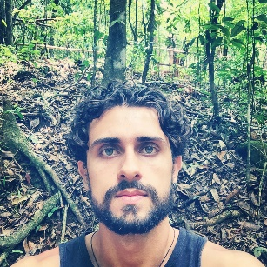
马智远 – Germano Pereira Matias
Translator/Teacher/ Reviser
Belo Horizonte, MG, Brazil
Telefone：+55 31 991990805
Skype: germano.p.matias
e-mail：germanopmatias@gmail.com
Education
Federal University of Minas Gerais
Graduated in Mining Engineering - 2014
Working with Translation: Theory and Practice. Understanding the basics of translation – Cardiff University – 2016, 16 hours
Localization Essentials – Udacity – 2016, 20 hours
Introduction to Game Localization – Udemy 2017, 40 hours
Experience
I’m a professional translator since 2016, having translated more than 3 million words, mostly on the English-Portuguese pair, with audiovisual material. My latest job in the dubbing industry was translating and adapting to Portuguese the Philippine TV show called Till I Met you into Portuguese. I currently teach Mandarin at the Confucius Institute (IC-UFMG) and I’m in the process of translating the classical Chinese novel 水浒传 – Water Margin into Portuguese.
Softwares and Cat Tools
Google Translator Toolkit; MemoQ; Microsoft Excel; Microsoft Word; OmegaT; Powerpoint; SDL TRADOS; Wordfast.
Languages
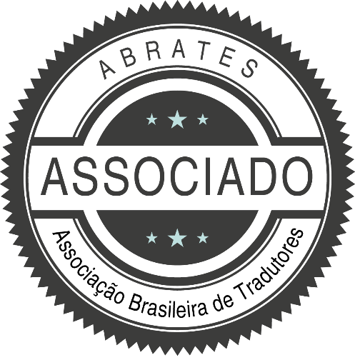
Brazilian Portuguese - Native
Mandarin – Fluent
English – Fluent
Latin - Advanced
Spanish - Advanced

