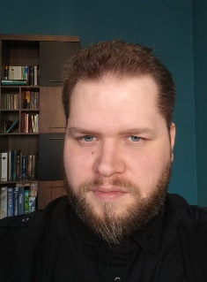
I am Timár Gábor, my native language is Hungarian. I graduated from the Premontrei Szent Norbert high school in Gödöllő and passed the advanced-level English language exam in 2003. From 2003, I studied physics and informatics at ELTE (Eötvös Lóránd University) after which I worked as a conference technician.
I have been working as a freelancer translator since November 2014 and translated about 8 million words in the Hungarian–English / English–Hungarian language pair.
I worked on projects in various fields including the following:
Extensive experience
- CNC machining, motor vehicles, building services (engineering and management), fire protection materials, information technology, electronics, electricity, materials physics, welding,
- medical devices, SSCP, PIL, clinical study materials, informed consent forms , in vitro diagnostics, orthopaedics, radiology, ultrasound imaging
- GDPR and other data protection materials, general terms and conditions, public procurement materials
- marketing and environmental (energetics, industry, other EU tenders) translations, industrial user and service manuals, health and occupational safety materials, HR-materials,.
Limited experience
- nuclear power plants, railway, architecture
- CRM systems (e.g. Microsoft Dynamics), various EU tenders
- dental materials
Among others, I worked on Sandvik Coromant, Pramet, Hilti, Mazda, Renault, Kia, Apple, Microsoft, Adobe, Autodesk, Epson, Fuji, Canon, Nikon, HMD, HP, Ericsson, Philips Healthcare, Samsung Medison, GlaxoSmithKline, BD Medical, Covidien, Stryker Medical, Fisher and Paykel, Smith & Nephew, Schneider Electric, Lincoln Electric, Morek, BME (Budapest University of Technology and Economics), UN and EU Environment Programme materials.
My daily capacity varies depending on the subject and some other factors; it is 1500 words at least and usually no more than 4000 words (weighted word count). I am willing to work on weekends as well with reduced capacity in case it is necessary to meet a deadline.
I am proficient in using memoQ, SDL Trados Studio, WordFast (I have no license currently), MateCat and Lionbridge software. I have experience in working with general software like MS Word, PowerPoint, Excel, PDF converting, OCR etc.

