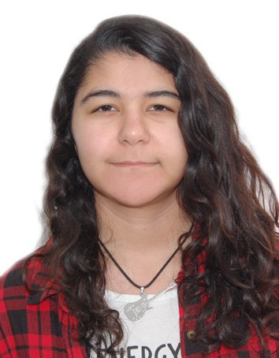FIDAN
JUMSHUDOVA
I n t e r p r e t e r
(English, Russian, Turkish, Azerbaijani)

30 September, 1998
PERSONAL INFORMATION
Kultur Mah. 8/6, Ankara, Turkey

Published an Article: Translators vs AI (2019)
ACHIEVEMENTS

Translated a Book: Basics of Computer Hardware (2020)
WORK EXPERIENCE

Translator
Atlas Translation Center | Baku, Azerbaijan 2018-2020
Learned from best translators of the Country Worked on multiple areas of interpretation

Freelance Interpreter
Since 2018
Written Translation Simultaneous Translation Consecutive Translation

English Teacher
Celt Colleges| Baku, Azerbaijan 2018-2019

EDUCATION

Number: +905526736553
CONTACT DETAILS

E-mail: cumshudova98@gmail.com
Baku Engineering University Faculty of Translation 2015-2019 Graduated with 3.75 GPA

Middle Eastern Technical University
Faculty of English Literature 2020-

BASIC SKILLS

MS Office

Smartcat

