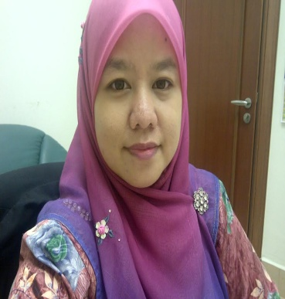

CV
Name : Farahidayu binti Mohd Yazid
Email : imanfarhana_09@yahoo.com , farahidayu@kehakiman.gov.my
Tel : 03-62094000 (office), 03-62094146 (fax)
Mobile : 011-18578430
Address: F-2-15, Flora Damansara, Jalan PJU 8/9, Damansara Perdana, Petaling Jaya, 47820 Selangor

Nationality: Malaysia

Date of Birth: 17th October 1982

Working objectives: Fast and efficient services, delivery before deadline, always satisfied customers, standard Malaysian prices.

Employer’s Name: High Court Civil NCVC 1, Aras 3, Sayap Kiri, Kompleks Mahkamah Kuala Lumpur, Jalan Duta, 50506 Kuala Lumpur.

Language: Malay>English (Specialization, all subjects)

Affiliated Agencies: Lawyers Firm.

Specialized in: Building & construction, Immigration/Judicial/Police, Legal, Business Contracts, Education, Health, Arts and Culture.

Mother Tongue: Malay.

