Job Application Form
personal information个人信息

姓 名  Name | 中文chinese | 程养浩 |  | 申请职位  Position |  |  |  | 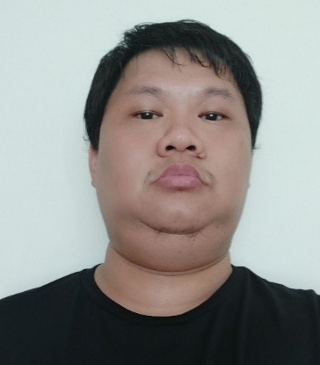
 | 英文English | Fahrudin |  | 性 别  Sex |  | Male
出生日期  Date of Birth |  | 01 November 1986 |  | 年 龄  Age |  | 36
身份证号  IC No |  |  |  | 婚姻状况  Marital Status |  | Married
护照号码  Passport No |  | C 6231038 |  | 身 高  Height |  | 170
护照有效期至  Passport Expiry Date |  | 12 oct 2025 |  | 体 重  Weight |  | 66
家庭住址  Home Address |  |  |  |  |  |  |  | QQ/WeChat | Fahrudin_cheng86
联系电话  Contact Number |  | 09157398525 |  |  |  |  |  | 外语水平  Language | Indonesia
家庭成员 Family Member
姓 名  Name |  | 亲属关系  Relationship | 出生日期  Date of Birth |  | 工作单位、地址  Name & Address of Company |  |  | 职 业  Occupation
Dewi.r |  | Wife | August 1987 |  | Pekanbaru
教育背景 Educational Background
开始时间  From |  | 截止时间  To | 学 校 名 称  Name of School |  |  |  | 专 业  Majore | 学 历  Qualification
1999 |  | 2001 | Kalam kudus |  |  |  | 中学
2001 |  | 2004 | Kartini |  |  |  | 高中
工作经历 Working Experience
开始时间  From |  | 截止时间  To | 公 司 名 称  Name of Company |  |  |  | 职 位  Position | 基本工资 Basic Salary
2007 |  | 2014 | Batam city condotel |  |  |  | Accounting | Rp 6.000.000
2019 |  | 2022 | SQT |  |  |  | 出入款 | 120.000 piso
自我评价  Self Assessment |  | I’m can speak and typing fluently includimg english, chinese and indonesian
以上填写内容我已仔细阅读过，全部资料由本人提供，如有虚假或仿造，本人承担一切责任
All the above information is submitted by myself.If it is false, I will be responsible for the result.
Applicant 申请人： fahrudin Date of filling the form 填表日期：14 dec 2022

