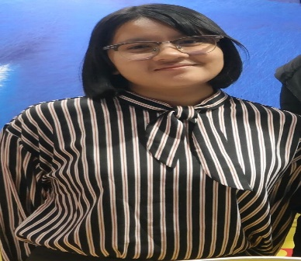 |  | Faghira Izzah Qistina Mohd Hisham  Translation, subtitling, transcription
profile |  | Work experience
Address:  N1-10-4, North Point, One Ampang Avenue, Jalan Ampang Utama 2/2, 68000, Ampang, Selangor.  Contact number:  +6018-292 7097  Email/Paypal Acc: faghiraizzah@gmail.com |  | [London Sandwich Co.]  [2017-2017]  [Worked as a kitchen staff, preparing ingredients and meals and a cashier]  [CookieNation] [Kitchen Staff, Cashier]  [2018 –2018]  [Worked as a kitchen staff, preparing ingredients and meals, and as cashier serving customers and in charge of payment and credit transactions]
Skills |  | Translation experience
- Translation  - Subtitling  - Transcription  - Proficient in English and Malay  - Skilled in Word, PowerPoint, & Excel  - Good time management  - Committed  Areas of specialisation:  - Social science  - Psychology  - Entertainment  - General translation  Language  English -> Malay  Malay -> English  Japanese -> English  Japanese -> Malay |  | [Subtitling for Disney]  [2020]  [I had done subtitling jobs for Disney in 2020 as a part time. I did English to Malay translation for several tv shows and movies:  - Prison Break  - The X Files  - Shanghai Knight  - Motherland: Fort Salem  - Futurama  - The Simpson]  [Transcription]  [2020]  [I had done transcription in English for an investment seminar conducted by a Singaporean investment company]
 |  | Translation Certificate
General Translation Certificate by Institute of Translation & Books, Malaysia (ITBM).

Service & Rates
SERVICES AND RATES
CURRENCY | USD PER SOURCE WORD
Translation (EN>MS), Daily Output: 1000 words | 0.05 -0.10
Proofreading | 0.025-0.05
Hourly charge | 20-30
Subtitling (EN > MS) | USD $2-$2.5 per minute
Subtitle Proofreading& Conforming | USD 1.00 per minute
Daily output | 2000 words/day

References
- Noorliza Othman
Senior translator/editor/proofreader
Contact number: +6012-640 1075
Email: fantagero38@gmail.com

