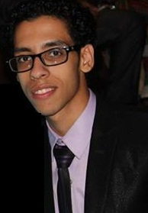

Name : Fady Ramses said Atwan .

Date of birth : 8/11/1993
Address : 39 Mostafa Basha ST, Hadayek El Zaitoun ,cairo
5 Menaa Agader ST , Miami , Alexandria
Email : modii_ramsesii@yahoo.com
Mobile Number: 01005346305

Objective:
Looking for a position in a reputable, progressive, and respectable organization that can offer very good opportunities by which I can improve my skills and gain more experience.

Education:

Spent the 3rd year at faculty of Beijing languages and culture in China

Studying at Faculty of Alsun , Ain Shams University Chinese department at the 4th year

Attended Courses:
- Chinese language courses at Ain Shams University
- HSKK Chinese Speaking Test
- Chinese Proficiency Test (HSK) Level 4 & Level 5
- Business Chinese Test (BCT)

Language & Computer skills:
- Arabic : Mother Tongue.
- English : Excellent
- Chinese : Fluent
- Polish : Good
- Computer : Intermediate
Training & Experience:
- 4 years as sales representative at princess Company
- 1 Month as teacher for English language at Beijing , China

Personal skills:
- Have a high positive way of thinking .
- Accommodate with any kind of people .
- Able to learn new tasks quickly .
- Able to work with team .
- Can work under pressure.
- Hard worker, Creative, Optimistic, Active, Organized.

