**Translator / proofreader / editor**

**English, French, Italian, German**

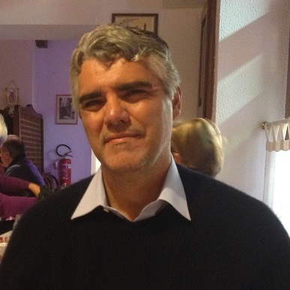

**Into Brazilian Portuguese**

Fabio R. de Araujo – therebox@yahoo.com

Phones: +55-21-3253-8770 / 21-99828-5147

Address: Estrada Velha da Tijuca, 1052 – casa 4

Alto da Boa Vista - Rio de Janeiro – RJ – Brazil

**Work Experience**

**Translator/Editor (From 1993 to today)**

**June 1993 - August 1994. VTI Rio. Full time Translator:** Translation/subtitling of film scripts etc. A small part of my work can be seen online in the links below: *La Grande Vadrouille* (from English, French and German – trailer only - https://www.youtube.com/watch?v=ZmWcxvB1j_E); Fatal Atraction, from English (https://www.youtube.com/watch?v=R7W94xChNIA) ; *O Poço e o Pêndulo* (The Pit and the Pendulum), from English - https://www.youtube.com/watch?v=KLaKml78-Tk&t=307s .

**August 1994-Today – Full-time/Freelance Translator and Reviewer/Editor** – Translation, editing and Proofreading: Most of the projects I worked on were related to computers, machinery, business-related, and pharma/medicine, to different companies.

**Main companies I translated for:**

**IT** (ATI Technologies, Adobe, Compaq, Corel, Creative Labs, Dell, Delphi, HP, Intel, IBM, Lexmark, Microsoft, Macromedia, Novell, Sybase, Sonic, Xerox etc.); **Films** (scripts, videos, VTI-Rio, National Geographic, Monsanto etc.); **Electronics** (appliances and small machines in general, Agis, Panasonic, Phillips, Sony, Honeywell, Kodak, Texas Instruments etc.); **Automotive/transportation**: (Harley Davidson, Ford, Jaguar, Enterprise, Alamo, Boeing, Caterpillar, Ponsse, John Deere, Sea-Doo etc.) **Telecom**: (3Com, Qualcomm, Nokia, Tim, Telecom Italia etc.) **Medicine/Pharma**: (Merck, Xerox, General Electric, Procter&Gamble, patents etc.) **Other subjects**: (Bayer, Dale Carnegie, Colcrete Eurodrill, Hydratight, Frigel, Fyrquel, Control Devices, Monsanto, Mabey Bridge, Fedex, Fontbonne, Dr. Brown’s, Emerson, Petrobras, Marriott Hotels, Casa da Moeda do Brasil, Principal (investments), Vecap, etc.) **In-house**: 6 months reviewing Windows 2000 for Bowne, and other shorter periods for the same company, 3 months for Logos Italy. Shorter periods for others.

**Language school owner. English Tutor (2002-2007) – and translator/editor**

During these five years, the business grew and had (at its highest point) about 200 students at the same time. I sold it to 2 employees as it was time consuming and not making enough money for me.

**US Publishing house owner (2009-2021) - and translator/editor**

Hundreds of books published, introductions written in English in a few books, books translated from French and English into Portuguese.

**Software**

SDL Trados 2021 (I have been using Trados since version 2 in the 1990s). Adobe Photoshop, MS Office, MS Windows. Experience using MemoQ and DejaVu for years.

**Education**

1990 – Software Engineering – Universidade Federal Fluminense (RJ, Brazil)

2000 – Certificate of Proficiency in English - Michigan University

2008 – History – Universidade Gama Filho, Brazil (RJ, Brazil)

2008 – International Relations (6 month post-graduation course, ADESG, RJ Brazil)

2018 – History in schools – R2 (1 year post-graduation course, SP Brazil)

2019-2022 - Online courses in universities (Harvard in the US, Federica in Italy, etc.)